Northern Spotted Owl
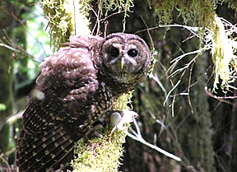

Northern Spotted Owls are listed as a threatened species under the Endangered Species Act. A threatened species is one that is “likely to become an endangered species within the foreseeable future throughout all or a significant portion of its range.” 16 U.S.C.A. §§ 1532. An endangered species is one that is “in danger of extinction throughout all or a significant portion of its range.” Id. According to the Oregon Fish and Wildlife Office, the Northern Spotted Owl population has declined at an annual rate between 2.9% and 5.9% since 1992.

Northern Spotted Owls thrive in old growth forests and prefer a forest canopy of several different tree species, with open spaces below the canopy that allow them to fly around and hunt beneath the lower branches.

Northern Spotted Owl are an “indicator” species. The fact that a Northern Spotted Owl can survive in an area indicates that areas is suitable for a diverse range of other plants and animals.

Northern Spotted Owls are territorial. When nests are located closer together, it’s a sign the population of prey in that particular area is greater.

Northern Spotted Owls don’t build their own homes. They often use nests abandoned by other species, such as ravens, raptors, and squirrels.

Northern Spotted Owls are carnivores. Favorite foods include mice, rabbits, voles, gophers, songbirds, shrew, opossum, rats, bats, snakes, and insects.

Divorce is uncommon. Northern Spotted Owls most often mate for life, and their numbers are often calculated in pairs.

In addition to concerns about habitat destruction, the Northern Spotted Owl’s existence is also threatened by the Barred Owl, which is native to eastern parts of North America. The Barred Owl is larger, more aggressive, and more adaptable than the Northern Spotted Owl.
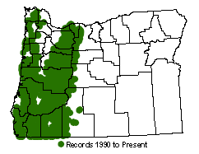
Where the Northern Spotted Owl is found.

Questions
(From an Owl’s Perspective)

I’m just a bird, why should anybody care about me?

If the Barred Owl is already threatening my existence, why does it matter if excessive logging disturbs my habitat?

I’m a big fan of the old trees, and lots of them. Do you think you can solve the problem of my decline by replanting?

What about thinning the forest? I get some trees, you get some trees, aren’t we all happy then?
Official Ballot

I identify most strongly with the following perspective. Mark only one choice and vote only once (this isn’t Chicago, after all). Give it to your group facilitator.

A. Friends and Lovers of Old Growth.

B. County Budget perspective.

C. Northern Spotted Owl perspective.

D. Millworker Perspective.

