County Budget Perspective
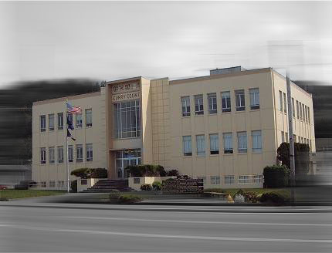

The United States, like federally-recognized Indian Tribes, enjoys sovereign immunity from state and local property taxation. If the O & C lands had not reverted from their former private owners to federal ownership, they would be subject to tax today. Congress has passed several laws with the overarching intent of providing counties with revenue from the lands that would have been taxable.

Federal law creates three potential sources of revenue for counties. Two of them are commodity-based -- rising or falling with the amount of timber harvest.
- O & C Act: 75% of gross timber revenues are payable to counties. Counties have elected to “plowback” -- i.e., pay to the federal government -- 25% of the gross to defray the federal government’s land-management costs.
- Payments in Lieu of Taxes (“PILT”)(since 1995). Payments under this law are adjusted down (to a floor) as payments under the O & C Act go up, or if the county elects to receive Secure Rural Schools (“SRS”) payments.
- Secure Rural Schools (since 2000). In its first year, this payment from U.S. to counties was pegged at the historic average commodity-based payments for 1986 - 1989. The amount of SRS payments stepped down each year, with a stated target of zero. Payments continue only because Congress has periodically reauthorized them.
O&C Payments are split among 18 counties, primarily in western Oregon. When adjusted for 2011 dollars, historical O&C Payments (including SRS) average $134 million from 1960-2011. With each successive extension of SRS (FY 2009 forward) the total payment (in 2011$) has declined from $136 million in 2001 to $40 million in 2011. Without the SRS extension, the O&C Counties would have received a total of $9 million in 2011 (based on 50% of timber receipts).

Counties use their general funds to pay for public safety, libraries, public health, assessment & taxation and many other services of significance to lawyers as practitioners and as citizens. When cuts must be made, they must come from this discretionary revenue.

In four counties, O&C payments in 2007 made up more than 50% of discretionary general fund revenue; and more than 20% in nine counties. The average of all the O & C Counties was 27%. Some examples: Douglas (81%); Lane (33%); Polk (23%); Benton (17%); Linn (11%); and Marion (3%).

Questions
(From a County Perspective)

Doesn’t the O & C Act create a trust of which counties are beneficiaries?

The O & C Act says that the federal government “shall” harvest timber to a specified volume each year. It hasn’t done that. Why isn’t the United States operating in violation of law?

Can the county declare bankruptcy? If it did, would access to state courts be eliminated?
Official Ballot

I identify most strongly with the following perspective. Mark only one choice and vote only once (this isn’t Chicago, after all). Give it to your group facilitator.

A. Friends and Lovers of Old Growth.

B. County Budget perspective.

C. Northern Spotted Owl perspective.

D. Millworker Perspective.

