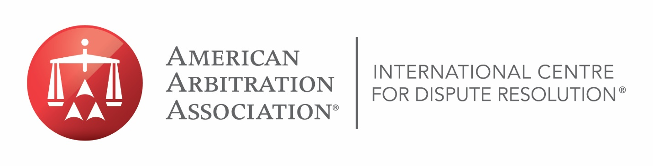
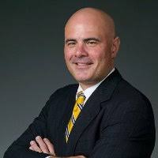
JEFFREY T. ZAINO, ESQ.
Jeffrey T. Zaino, Esq. is the Vice President of the Commercial Division of the American Arbitration Association in New York. He oversees administration of the large, complex commercial caseload, user outreach, and panel of commercial neutrals in New York. He joined the Association in 1990. Mr. Zaino is dedicated to promoting ADR methods and services.
He has also written and published extensively on the topics of election reform and ADR, including several podcasts with the ABA, TalksOnLaw, and Corporate Counsel Business, and has appeared on CNN, MSNBC, and Bloomberg to discuss national election reform efforts and the Help America Vote Act. He was deemed a 2018 Alternative Dispute Resolution Champion by the National Law Journal and received awards for his ADR work from the National Academy of Arbitrators, Region 2 and Long Island Labor and Employment Relations Association. In 2022 he received the Alocott-Leber-Younger Committee of the Year Award from the New York State Bar (NYSBA) Commercial and Federal Litigation Section, and in 2023 the Chairman’s Award, NYSBA Dispute Resolution Section.

