**Pauline Newman IP American Inn of Court General Meeting – September 25, and October 8, 2024 Meeting Notes.**

**September 25, 2024 Meeting Notes:**

**Location: Buchanan Ingersoll & Rooney in Alexandria, VA.**

**Social Hour began at 6pm, Formal program began at 7pm.**

At 7 pm, Andreas began the introductory remarks and welcomed new prospective members by going around the room and having new or prospective members give their name, background and one thing they are looking forward to as a member of the Inn.

Andreas then continued the new member orientation presentation with slides on the following topics:

* Members of the executive committee for 2024-2025
* An infographic on the American Inns of Court
* The mission, vision and creed of the American Inns of Court
* Background on the Pauline Newman IP American Inn of Court
  + Founded in 2011
  + Part of the Linn Inn Alliance of IP Law
  + Named after Judge Pauline Newman of the Federal Circuit
  + Is a Platinum Level Inn
* Member expectations – commitment of the Inn to provide an enriching experience for members
* National member benefits
* Mentoring groups are forming and pupilage groups will be established, first by finding a pupilage group leader, and then filling in the groups afterwards.

Andreas invited everyone to email Andreas or James Wilcox with questions .

James Wilcox spoke briefly about the mentoring opportunities available - that the available mentor group is diverse and includes Judges, patent examiners, and patent practitioners.

At 7:20pm, the speed-networking portion of the program began, and continued till adjournment at 8pm. The speed-networking portion was divided into 5 minute increments during which each participant was paired with another participant to ask and answer 2 or more questions, as given on a deck of cards distributed over the conference table.

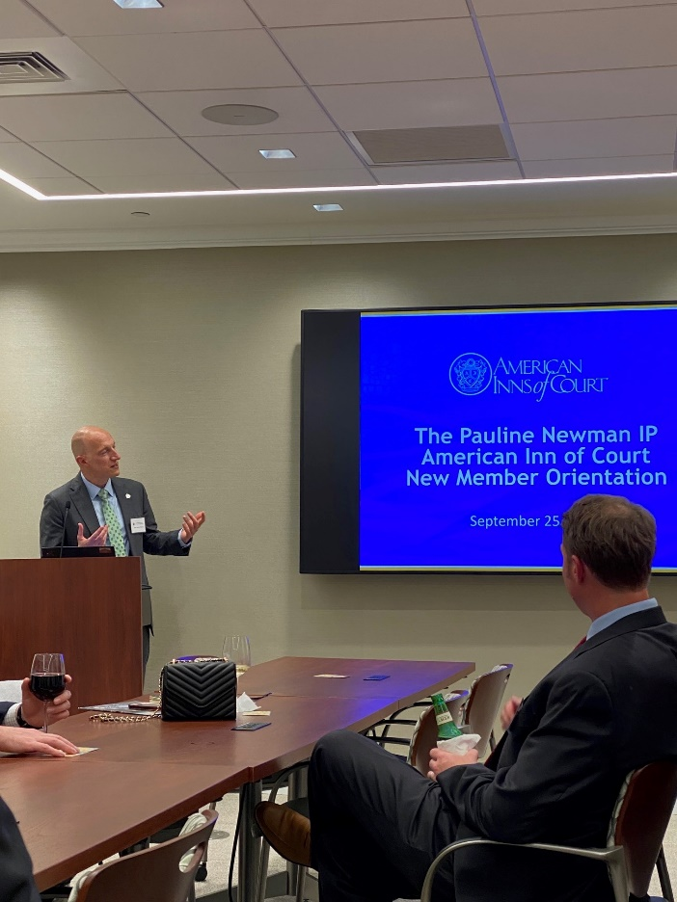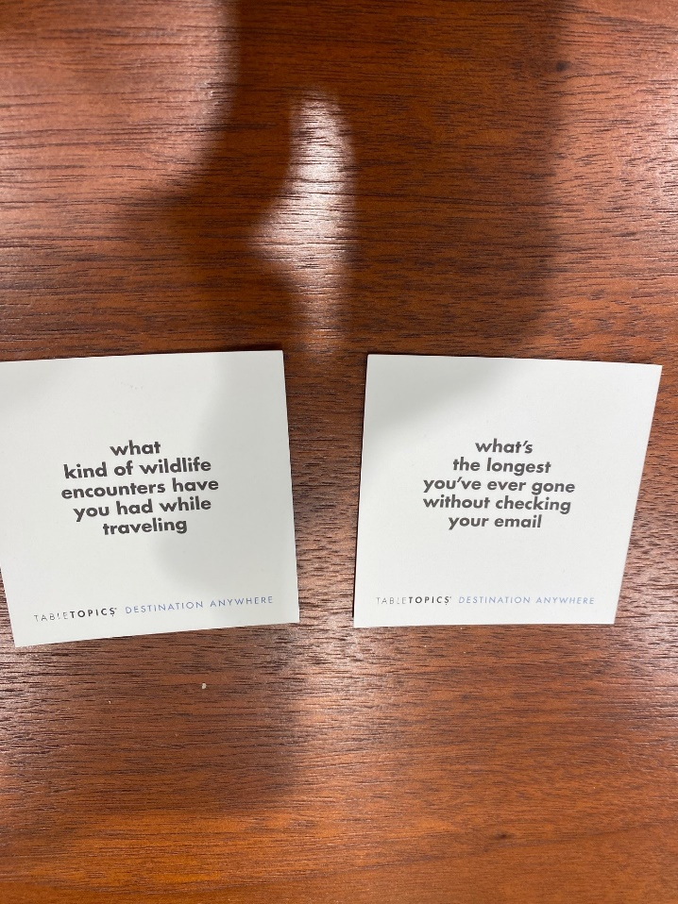

**October 8, 2024 Meeting Notes:**

**Location: Crowell & Moring in Washington DC.**

**Formal program began at 6:30pm, Social Hour began at 7:30pm.**

The formal program for this evening was a tri-Inn (Honorable William C. Conner Inn of Court (New York), the Pauline Newman IP American Inn of Court (D.C.), and the Richard Linn American Inn of Court (Chicago) videoconference based Jeopardy-Style competition.

Teams for the trivia challenge were formed by location (D.C., New York or Chicago) and sub-teams within each location.

Topics for the questions included:

* Recent Developments
* Trademarks
* Copyrights
* Patents
* Do You Know Your History?
* Just for Fun

A final question was asked and all sub-teams were asked to wager an amount, then the question was revealed, and all sub-teams had to provide an answer.

The grand winner was D.C. Team 1, who was congratulated, and then all judges present at each meeting were invited to speak. Judge Newman spoke some inspiring words on behalf of her Inn.

After the formal program ended at 7:30, a social hour continued until 8:30 until the meeting ended.

