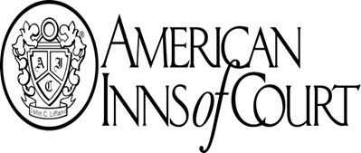
2o
Submit your application by
June 28, 2023 to:

Bryan AIC Administrator
2522 North Proctor, #411
Tacoma, WA 98406

Or email to the Bryan AIC Administrator: Mary Ann Romo mara911@aol.com

Dues for the 2023/2024 year will be $575 payable by September 1, 2023, which includes six CLE credits and refreshments

New members must attend at least 5 out of 6 of the regular meetings annually to remain in good standing
About the Inn

The Honorable Robert J. Bryan American Inn of Court APPLICATION

Chapter XXV Tacoma, Washington

NEW MEMBER APPLICATION/NOMINATION 2023/2024

The American Inns of Court (AIC) are designed to improve the skills, professionalism, and ethics of the Bench and Bar. The Honorable Robert J. Bryan American Inn of Court is a long-standing local chapter of the American Inns of Court, America’s oldest, largest, and fastest growing legal mentoring organization. For over 35 years the Bryan AIC has provided judges, lawyers, law students, and law professors a unique opportunity to participate actively in developing a deeper understanding and sense of professionalism, in achieving higher levels of excellence, and in furthering the practice of law with dignity and integrity. The Bryan AIC continues its outreach by seeking new members who share the values embodied by the American Inns of Court.

Meetings and Membership

The Bryan AIC meets one Monday evening per month, September through May, both to share a meal and to hold programs and discussions on matters of ethics, skills and professionalism, with the goal of fostering more effective advocacy and a keener ethical awareness. Members who attend each of our regular programs also earn six WSBA-approved CLE credits per year. Our Members learn side-by-side with some of the most experienced judges and attorneys throughout our communities.

The meetings begin at 5:30 pm with a CLE component followed by a dinner meeting; attendance at both the CLE and the dinner meeting is required. Membership to the Bryan AIC is limited to no more than 80 active members. Because of this, we must adhere to a strict attendance policy where new members must attend at least 5 out of 6 of these meetings to remain in good standing. The Bryan AIC’s meetings are held on a fully in-person basis.

Annual membership dues to the Bryan AIC for the 2023/2024 year will be $575, which covers national and local membership, 6 CLE credits and 9 dinners. Student dues are $214.

Please provide the following information for membership in the Bryan AIC for the next term. Please attach your resume and submit your application by June 16, 2023.

Your Name:
Employer, Firm, or Law School:
Address:
Phone:
Email:
Website:

WSBA #: __________ Number of total years admitted (all states): ____

Prior Inn Member? [ ] Yes [ ] No If “Yes,” year(s) and Inn: ______________________

If you are a prior Inn member, please explain the circumstances under which you left the Inn, including but not limited to any attendance or disciplinary issues.

Your “Category”: [ ] Judge [ ] Attorney [ ] Law Professor [ ] Law Student

Please briefly describe your practice and practice areas, or legal education focus (if applicable):
_____________________________________________________________________________
_____________________________________________________________________________
_____________________________________________________________________________
_____________________________________________________________________________
_____________________________________________________________________________

Please tell us why you seek Membership in the Bryan AIC:
_____________________________________________________________________________
_____________________________________________________________________________
_____________________________________________________________________________
_____________________________________________________________________________
_____________________________________________________________________________
_____________________________________________________________________________
_____________________________________________________________________________

Please describe how you share the values embodied by the American Inns of Court:
_____________________________________________________________________________
_____________________________________________________________________________
_____________________________________________________________________________
_____________________________________________________________________________
_____________________________________________________________________________
_____________________________________________________________________________

By signing and submitting this application you hereby certify that the above is true and correct.

______________________________________________ _____________________________
Applicant’s Signature Date

If someone is nominating you for membership, please ask them to fill this portion out.
Nominator’s Name (optional):

______________________________________________________

Please describe why you have nominated this person for Membership in the Bryan AIC:
_____________________________________________________________________________
_____________________________________________________________________________
_____________________________________________________________________________
_____________________________________________________________________________
_____________________________________________________________________________
_____________________________________________________________________________
_____________________________________________________________________________

Please return your application by mail to: Or please return your application by email to:

The Honorable Robert J. Bryan Bryan AIC Administrator:
American Inn of Court, Chapter XXV Mary Ann Romo
2522 North Proctor, #411 mara911@aol.com
Tacoma, WA 98406

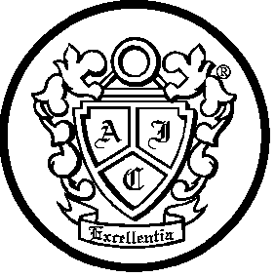
THANK YOU FOR YOUR INTEREST IN
THE HONORABLE ROBERT J. BRYAN AMERICAN INN OF COURT.

