This email is to confirm that a virtual mediation has been scheduled in the **Boles v. Boles** matter for **Monday, June 1, 2045, from 9:00 a.m. until 5:00 p.m.** The mediation will be held via Zoom (the use of Zoom is at no cost to the mediation participants. The Zoom mediation, as you will see, is virtually the same as attending mediation in person.  Accordingly, both parties will be in private virtual rooms with their attorneys and will not have to see or hear the other party or the opposing attorney.  I will go back and forth between the rooms to facilitate the negotiations.  Upon reaching an agreement, I will send you all a link to execute the settlement agreement via Docusign (the use of Docusign is also at no cost to the mediation participants).

In this email you will find the following:  the zoom meeting link and password (highlighted in yellow below – alternatively the dial in number if you do not have a computer or smart device), simple zoom instructions (below), and detailed instructions for the virtual mediation (attached).  ***All participants will need to review the foregoing and ensure they have downloaded the zoom app (free version) in advance of the mediation.***

If any participants have questions about Zoom not elsewhere provided in this email, please visit my website at <https://boleslawoffice.com/mediation-practice/virtual-mediations-2/>

The mediation rate is $250.00 per hour and must be paid in full by the Parties on the date of the mediation via Venmo or credit card. In view of the fact that I have set aside this time on my calendar, I do have a policy of charging a two-hour minimum for the mediation session. The Parties shall be share in responsibility for the payment of the mediation in accordance with the division of responsibility in the Notice of Mediation Conference.

As I have set this time aside on my calendar, I request that you notify my office at least forty-eight (48) hours in advance if the mediation is to be cancelled. If cancelled in less than forty-eight (48) hours, you will be charged a cancellation fee of $500.00.

Because of the confidentiality rules governing mediation, third parties (significant others, friends, loved ones) are not permitted to attend the mediation unless the Parties mutually agree upon the same in advance of the mediation session.

Thank you for expressing your confidence in me by requesting me to serve as your mediator. I look forward to working with you and your clients towards an amicable resolution of the issues.

Sincerely,

Amber Boles, Esquire

Certified Florida Supreme Court Mediator

AMBER BOLES is inviting you to a scheduled Zoom meeting.

***Topic: Mediation: Boles v. Boles***

Time: May 11, 2020 09:00 AM Eastern Time (US and Canada)

Join Zoom Meeting

<https://us02web.zoom.us/j/XXXXXXXXX>

Meeting ID: XXX XXXX XXXX

Password: XXXXXXX

One tap mobile

+13017158592,,XXXXXXXX#,,1#, XXXXXXXXX# US (Germantown)

+13126266799,, XXXXXXXX#,,1#, XXXXXXXXX# # US (Chicago)

Dial by your location

        +1 301 715 8592 US (Germantown)

        +1 312 626 6799 US (Chicago)

        +1 929 205 6099 US (New York)

        +1 253 215 8782 US (Tacoma)

        +1 346 248 7799 US (Houston)

        +1 669 900 6833 US (San Jose)

Meeting ID: XXX XXXX XXXXX

Password: XXXXXXXX

Find your local number: <https://us02web.zoom.us/u/kjzf58Gk4>

***Step 1 (ZOOM SOFTWARE)***

Before joining a Zoom meeting on a computer or mobile device, you can download the Zoom app. The most popular method clients like to use is a smart phone or an iPad or tablet with video. Installation is super easy and takes less than a minute.

The application can be installed on either an iOS or Android ready devices by searching for **ZOOM Cloud Meetings,** or you can download it by clicking an image below.

[cid:image002.png@01D60C35.ACCBB680](https://itunes.apple.com/us/app/id546505307)           [cid:image003.png@01D60C35.ACCBB680](https://play.google.com/store/apps/details?id=us.zoom.videomeetings)

If you have a laptop or desktop computer with a camera & microphone you can install the application by clicking the image below for a manual download.

[cid:image004.png@01D60C35.ACCBB680](https://zoom.us/client/latest/ZoomInstaller.exe)

If you haven’t installed the software prior to the meeting, don’t worry you will be prompted to download and install Zoom when you click a *join link* to a meeting.

***Step 2 (JOIN A MEETING)***

Your email invite will look similar to this example below (YOUR INVITE IS ABOVE).

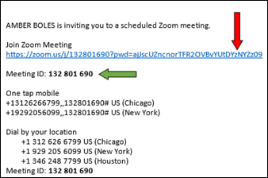

If have already installed Zoom on your device, its simple click the *Join Zoom Meeting* in your email or calendar invitation. *(indicated with the red arrow).* Depending on your default web browser, you may be prompted to open Zoom.

Each meeting has a unique 9, 10, or 11-digit number called a meeting ID that will be required to join a Zoom meeting *(indicated with the green arrow)*. If you are joining via telephone, you will need the teleconferencing number provided in the invite.

Your next screen will request you to join the audio of the meeting, typically the Call using Internet Audio is the best choice.

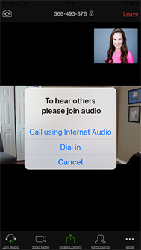

***Step 3 (WAITING & MEETING ROOM)***

After your audio is joined you will be placed in a virtual Waiting Room. Think of it as a lobby for each attendee. Once all participants have joined the meeting you will be admitted into your own private room with your attorney if you have one attending. Your screen will look like this below until being placed in your room.

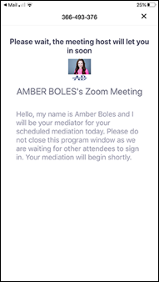

Your mediation will begin and if there are any questions you have I can answer them at that time. I am looking forward to meeting with you and resolving your issues.