Judge Paul “Bill” Glenn Professionalism Award
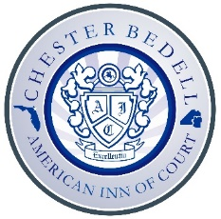

Overview
Through this award, the Chester Bedell American Inn of Court seeks to recognize a lawyer or judge whose life and practice, like those of Judge Glenn and the recipients of the American Inns of Court professionalism awards, display sterling character and unquestioned integrity, coupled with ongoing dedication to the highest standards of the legal profession and the rule of law.
Criteria
- The nominee must be alive at the time of the nomination.
- The nominee must be an active member, emeritus member, or alumnus of the Chester Bedell American Inn of Court.
- The recipient must be a first-time recipient of the award.
Procedures
- A summary of the award overview, criteria, and procedures will be placed on the Inn’s website.
- At the October meeting each year, the President will summarize for all active members the award overview, criteria, and procedures.
- Nominations may be made by anyone (members or non-members) to any member of the Executive Committee in any manner, however informal, and at any time before the February meeting of the Executive Committee.
- At its February meeting each year, the Executive Committee will consider nominees for the award and, if warranted, select a recipient.
- To avoid diluting the meaning of the award, the award need not be given annually and should be given only if a lawyer or judge is truly deserving.
- The recipient is recognized with a plaque at the Chester Bedell American Inn of Court’s annual dinner by the President or someone selected by the President, with preference for someone who had been close to Judge Glenn.
- The recipient will be added to a list of recipients of the award on the Inn’s website.

