Plaintiff Queen brings an action for Declaratory Judgment seeking a determination that she is the fairest of them all. Snow White counterclaims. Plaintiff presents Ms. Mirror, a purported expert in beauty. Defendant presents “Doc” a plastic surgeon. The case centers on expert testimony and which standard should be applied: Frye or Daubert. Judge Sleepy turns to the audience for help....

ALL RISE – IN THE MATTER OF QUEEN V. SNOW WHITE, JUDGE SLEEPY PRESIDING.
ACT I
THE QUEEN AND
MS. MIRROR

Scene 1
Ms. Mirror – a Perfect Reflection Beauty expert based on years of experience.

Scene 2
Sneezy’s Voir Dire of Ms. Mirror and objection under Frye; indisputable bias towards Queen.

ACT II
SNOW WHITE AND “DOC”

Scene 1
“Doc’s” Background and Training - Face Mapping Methodology

Scene 2
What Type of Surgeon is “Doc?” Is He Peer Reviewed? Can He See?
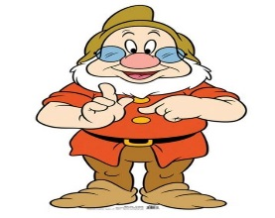
ACT III
“DOC” IS ADMITTED AS AN EXPERT
Scene 1
Prior Relationship with Queen – Who is Dr. Dopey?

Scene 2
“Doc” is being paid in violation of Rule 4-3.4

Scene 3
Grumpy gets personal!

Scene 4
An Apple and A Prince!

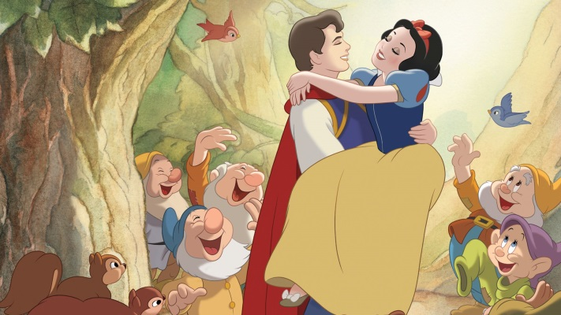

GRAY’S INN
Playwright

ALISON BAKER
CAST

HOST - WILL GOEBEL
Judge Sleepy - Judge Paige Gillman
The Queen - Nalani Gordon
Snow White - Nicole BaRNa
Grumpy, Esq. - JEAN MARIE MIDDLETON
Sneezy , Esq. - SHARI ELESSAR
Ms. MirrOR -Rebecca McFadden
Doc - Alison Percy
Happy - Andrea Trax
Bashful - Allison ForsTer
Dr. Dopey - GENNY BERNSTEIN
the Prince (and his Horse) - BRANDON WEITZMAN

MODERATORS
Judge Paige Gillman & Ashley Houlihan

LYRICS & DANCE
Jean Marie Middleton

GRAY’S INN Production Crew

Coordinator – Shari Elessar
Script Editor - Andrea Trax
Powerpoint– Ashley Houlihan
POWERPOINT ASSISTANCE - GENNY BERNSTEIN;Ana Cristina Maldonado, bRANDON WEITZMAN
Planning & Production – Nicole Barna, Genny Bernstein, Alexcia Cox, Judge Paige Gillman, Nalani Gordon, Rebecca McFadden, Jean Marie Middleton, Alison Percy, Susan St. John;
Research – Allison ForsTer, Judge Gillman,Will Goebel, Nalani Gordon; Programs & PROPS – Susan St. John

GRAY’S INN PRESENTS

THE QUEEN
versus

SNOW WHITE
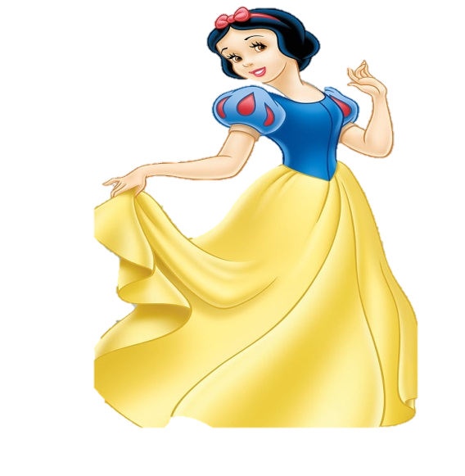
Who is the Fairest of them all?

