The April 9, 2019, Giles S. Rich American Inn of Court meeting had a presentation entitled Artificial Intelligence and the Internet of Things in IP: What does the Future Hold? The presentation featured an AI panel discussion moderated by Judge Susan Braden. Speakers included Andrei Iancu, Under Secretary of Commerce for Intellectual Property and Director of the USPTO; Lynn Parker, Assistant Director for Artificial Intelligence at White House Office of Science and Technology Policy (OSTP); and Sree Gadde, Blue Tree Allied Angels, an AI venture capitalist
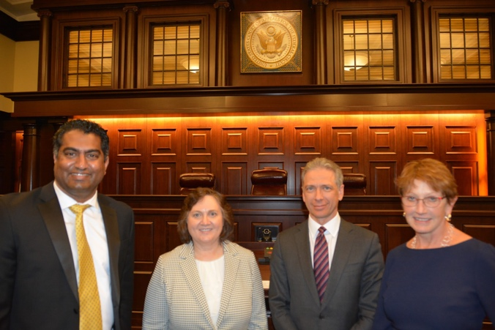
(The February speakers and moderators, right to left, as in bold above.)
The panelists discussed leading issues arising from AI and Big Data affecting IP law and policy, including changing U.S. government policies; potential revisions to USPTO examination policy and operations; the legal reforms under consideration for the new challenges of the AI revolution; and the impact on investment and the legal profession. The also presented various challenges and opportunities ushered in by AI and those being considered and implemented by the U.S. government and private sector stakeholders. The discussion included the possibility of protecting machine-made art and inventions, including could a painting made by software that had been trained on the work of a master painter be copyrighted and if so, who would hold the copyright, the software developer, the program, the artist (or the artist’s estate).
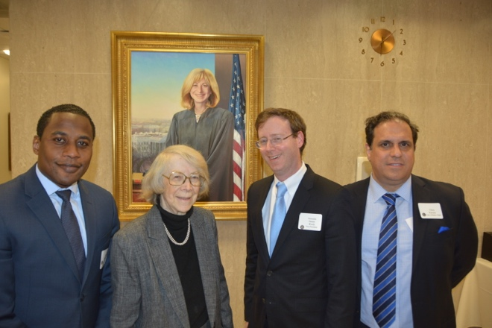
(Judge Pauline Newman, incoming Inn President Administrative Patent Judge James Worth, and Inn members pose before Chief Judge Prost’s portrait.)
Director Iancu spoke about the PTO’s role in fostering innovation and the interplay with current issues with Section 101. Lynn Parker spoke about the White House’s goals. Sree Gadde provided perspective from the VC area, and what he (and his company) looks for in determining how to invest in startups and where companies they invest in should focus on protecting their IP. 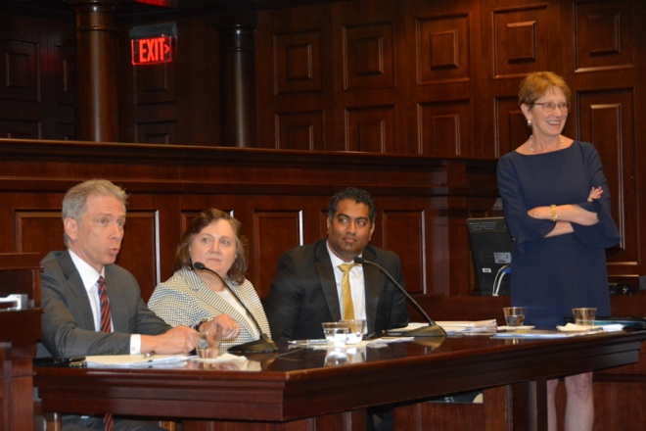
The meeting concluded with a reception held at the Dolly Madison House.
If there are any questions or concerns, please feel free to reach out to Kiley White at whitek@cafc.uscourts.gov.

