On Tuesday, February 19, 2019, the Giles S. Rich American Inn of Court held its first off-site program of the year, Competency of Practice, Wellness, and/or Career Longevity, at The George Washington University Law School. The event focused on substance abuse, well-being, and other increasingly important personnel issues in patent law, ones that are increasingly gaining national attention. In particular, it focused on alcohol, substance abuse, and means of seeking help for practicing lawyers.
During the 2018-2019 term, the GSR Inn introduced a new program, in which our local law schools hosted a program, and students and faculty from a particularly law school were invited to attend and participate as guests of our current Law Student Pupils. The initiative allows GSR to engage with local area law schools to encourage the next generation of lawyers to promote and practice professionalism, ethics, civility, and excellence. For the GW event, Dean John Whealan and GW students were encouraged to attend and learn about this important topic.
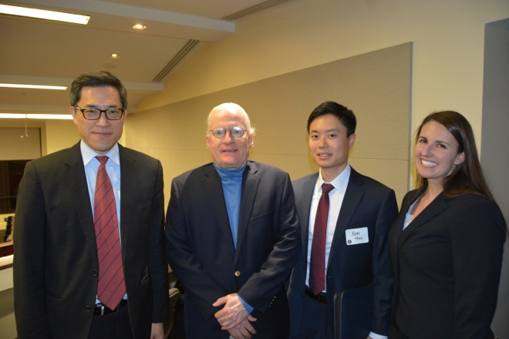
A recent ABA study found that between 21 and 36 percent of currently-practicing lawyers are problem drinkers, and an equally staggering percentage of attorneys suffer from some level of depression, anxiety, or stress. The parade of difficulties among members of the profession, including suicide, work addiction, sleep deprivation, and job dissatisfaction, all contribute to the serious and often fatal effects of substance abuse that inhere in the profession. Notably, younger lawyers in the first ten years of practice and those working in private firms are the most at risk and experience the highest rates of problem drinking, addiction and depression, with many of these problems beginning in law school. The program will raise awareness of the complex issues surrounding lawyer well-being through the lens of different stakeholders in the legal community.

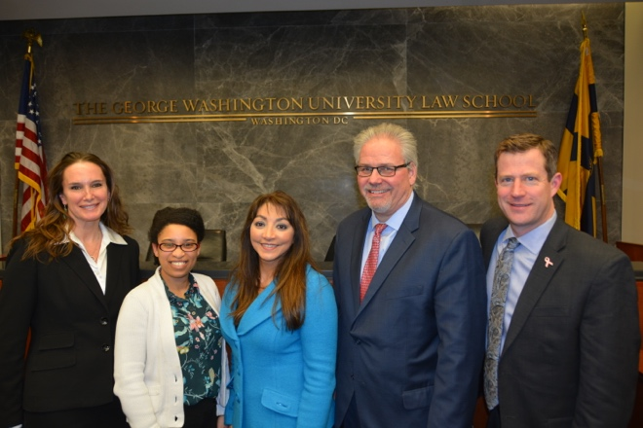
(Our February speakers and moderators, left to right, as in bold below)
The program featured a keynote speech from Laurie Besden, Esq., Executive Director of Lawyer Concerned for Lawyers—Pennsylvania, who shared in detail her first-hand journey with addiction and recovery. The even followed with a panel discussion including Dr. Jessica Floyd Alexander, the Director of the Wellness Program at the George Washington University School of Law, who discussed GW’s almost unique focus on offering resources, such as Dr. Alexander, to law students and faculty in an attempt to head substance abuse off during law school, when problem behavior frequently begins; Dahlia George, Esq., a staff attorney at the USPTO’s Office of Enrollment and Discipline, which created a new disciplinary diversion program specifically for IP practitioners whose health issues have led to ethical violations; moderator Michael McCabe, an expert on ethics in patent law; and Kerry B. McTigue, Esq., and IP partner at Cozen O’Connor, which is a signatory to the ABA’s “wellness pledge.”
The important discussion highlighted the dangers of succumbing to substance abuse for those engaging in high-stakes, demanding professions, and featured testimonials from the audience during the question-and-answer portion of the panel.
The meeting, hosted by the George Washington Law School and the Giles S. Rich American Inn of Court, was held in Listner Hall featured a reception after the event in the lobby of the GW law school. It was both well-attended and well-received.
If there are any questions or concerns, please feel free to reach out to Kiley White at whitek@cafc.uscourts.gov.

