On November 13, 2018, The Giles S. Rich Inn of Court hosted its November member meeting, consisting of a program meant to encourage interest in pro bono opportunities to represent appellants before the Federal Circuit. The official program, Pro Bono Representation in Veterans and MSPB Appeals, featured a panel discussion moderated by Philip Sternhell (DOJ, Civil Division) (successful pro bono advocate at CAFC when in private practice) (right).
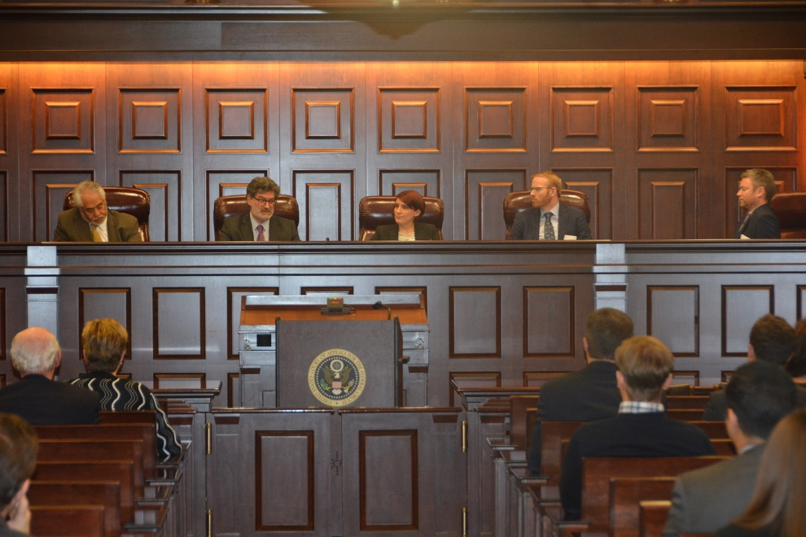
(The speaks as listed below left to right, with Mr. Sternhall on the far right.)
The panel featured (left to right in the above) The Honorable Jimmie Reyna of the U.S. Court of Appeals for the Federal Circuit, Ronald Weiss (Administrative Judge, U.S. Merit Systems Protection Board), Benjamin Herbert (Kirkland & Ellis; FCBA Pro Bono Committee Co-Chair), and Mel Bostwick (Orrick, appellate litigator and successful veterans pro bono advocate). This was a joint meeting with the Federal Circuit Bar Association.
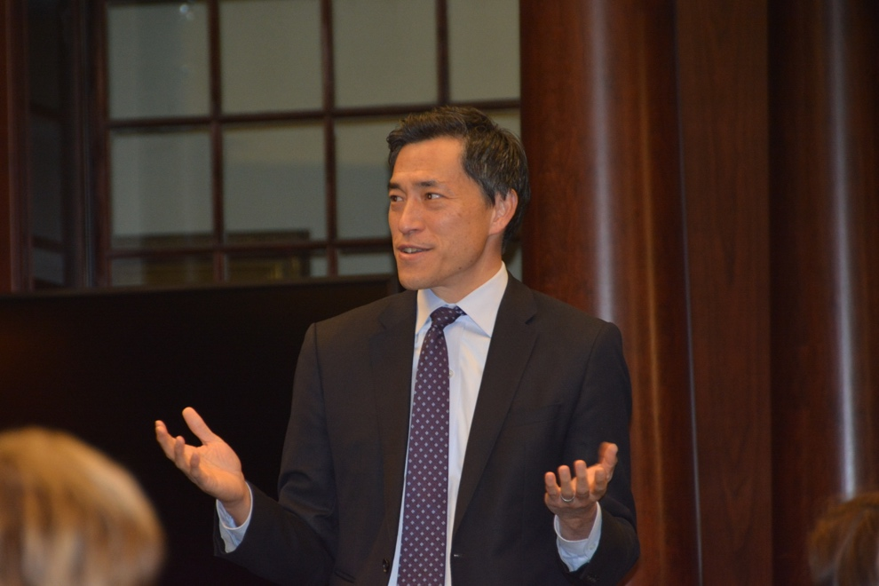
(Inn President Judge Raymond Chen introduces the speakers.)
Inn President Judge Raymond Chen gave brief opening remarks, and introduced the panel.
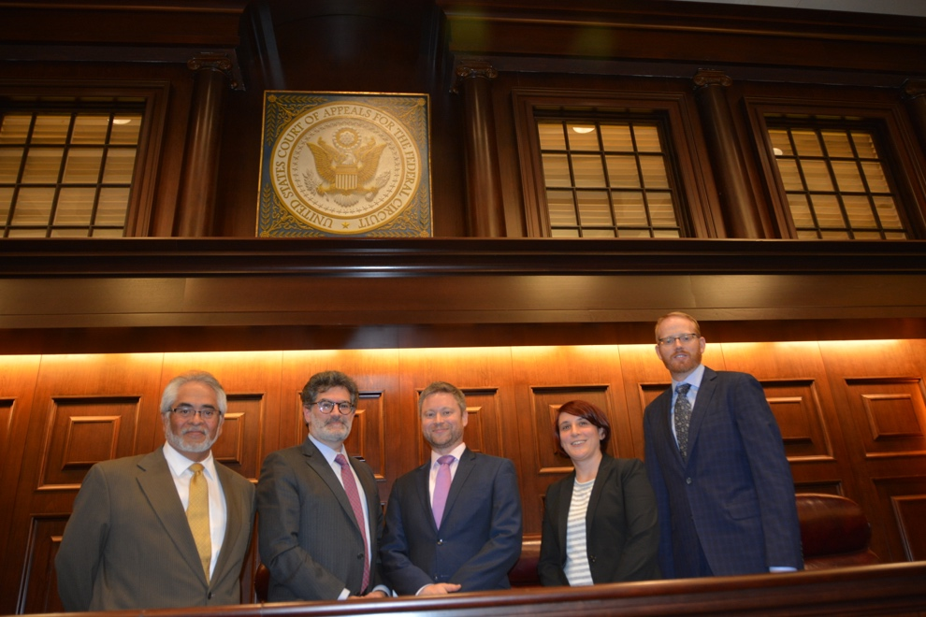
(The speakers, from left to right as listed above in bold)
There was helpful information provided about how to participate in pro bono programs of different types through the Federal Circuit Bar Association. The panelists shared their experiences on the demands and rewards involved.
The pre- and post-meeting reception was held in the Dolly Madison House, and was well-attended. If there are any questions or concerns, please feel free to reach out to Kiley White at whitek@cafc.uscourts.gov.

