On Tuesday, March 19, 2019, the Giles S. Rich American Inn of Court held its second-to-last program of the 2018-2019 term. The program, Advanced PTAB Practice, focused on emerging trends in PTAB practice that impact strategic decisions for stakeholders.
The Honorable Raymond Chen of the U.S. Court of Appeals for the Federal Circuit opened the evening’s program with brief remarks introducing the audience to the topic and moderated the discussion.
(Inn President Judge Raymond Chen)
The outstanding panel consisted of members from all areas of PTAB practice. Moderated by Adam Shartzer of Fish & Richardson, the panel consisted of Deputy Chief Administrative Patent Judge Jacqueline Bonilla of the PTAB; Administrative Patent Judge (and longtime member) Barry Grossman; Jonathan Strang, a partner at Latham & Watkins; Eldora Ellison, a partner at Sterne Kessler; and Cory Myers, in-house patent counsel at EchoStar Corporation (left to right, below).
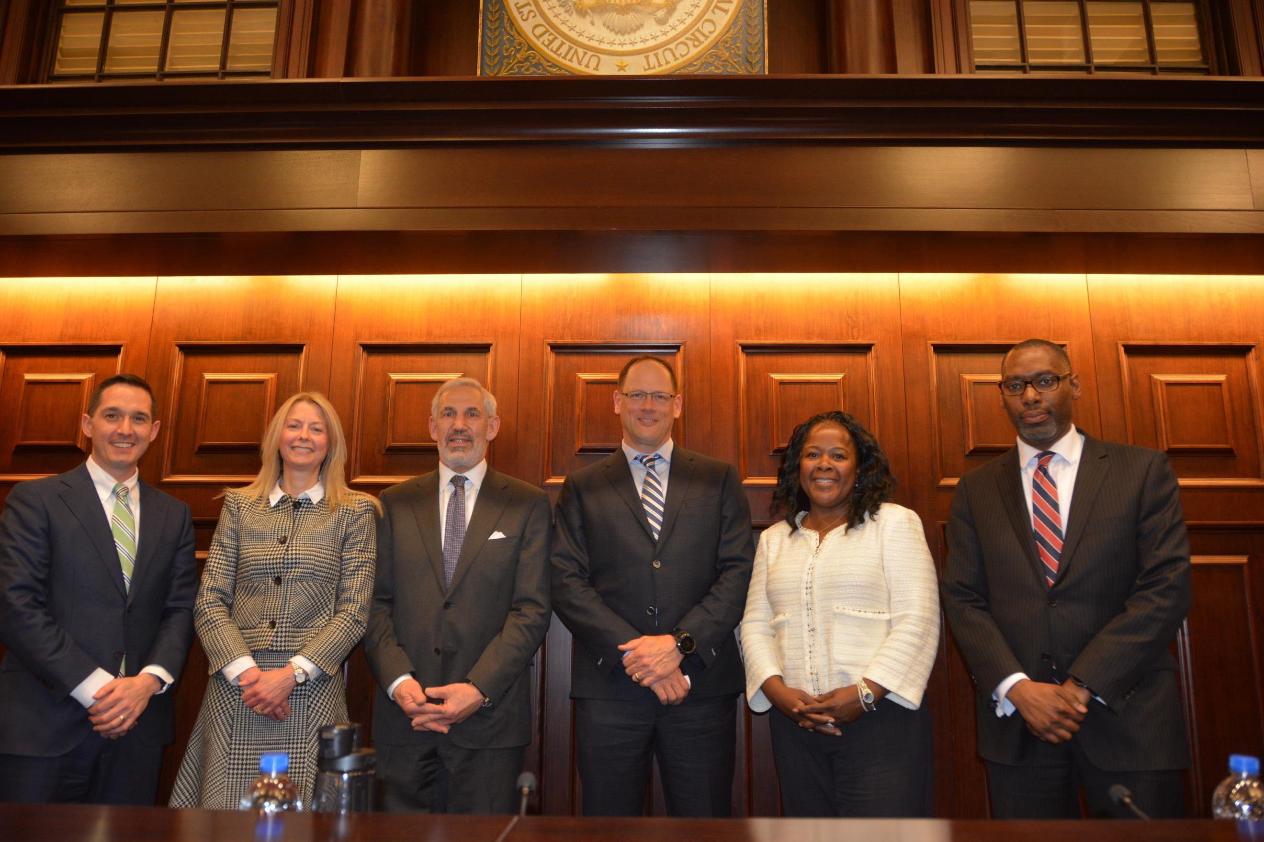
(The March speakers, as listed above from left to right)
Among other areas, the panel discussion covered the recent changes to the PTAB’s Standard Operating Procedures, including the newly developed Precedential Opinion Panel, and the amendments to the PTAB’s Trial Practice Guide. This, coupled with change in how the Board administers its deference and how it has dealt with the SAS and Oil States decisions, as well as the 101 examiner guidance, meant the panel had ample topics to discuss that reverberate across the PTAB practice landscape. The panel discussion covered many topics, including amendment practice, precedential opinion panels, and the impact of SAS at the PTAB and across parallel district court litigation.
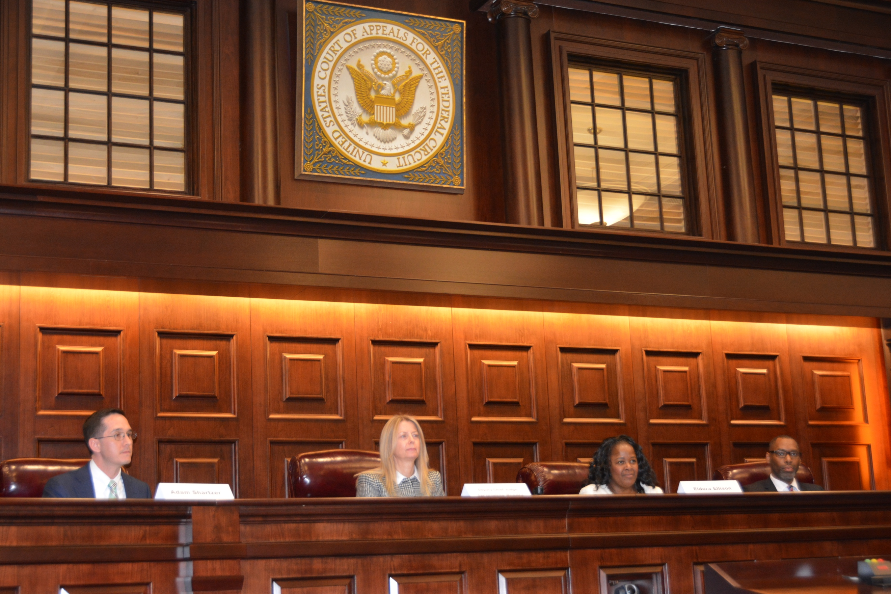

(responding from the bench)
The last regular monthly Giles S. Rich American Inn of Court meeting, the event featured an initial reception and subsequent cocktail hour, over which practitioners socialized and discussed the topics raised by the panelists.
If there are any questions or concerns, please feel free to reach out to Kiley White at whitek@cafc.uscourts.gov.

