On September 26, 2018, The Giles S. Rich Inn of Court met to discuss standard-essential patents (SEPs), fair, reasonable, and non-discriminatory (FRAND) licensing, and other aspects of standards-related patent disputes.
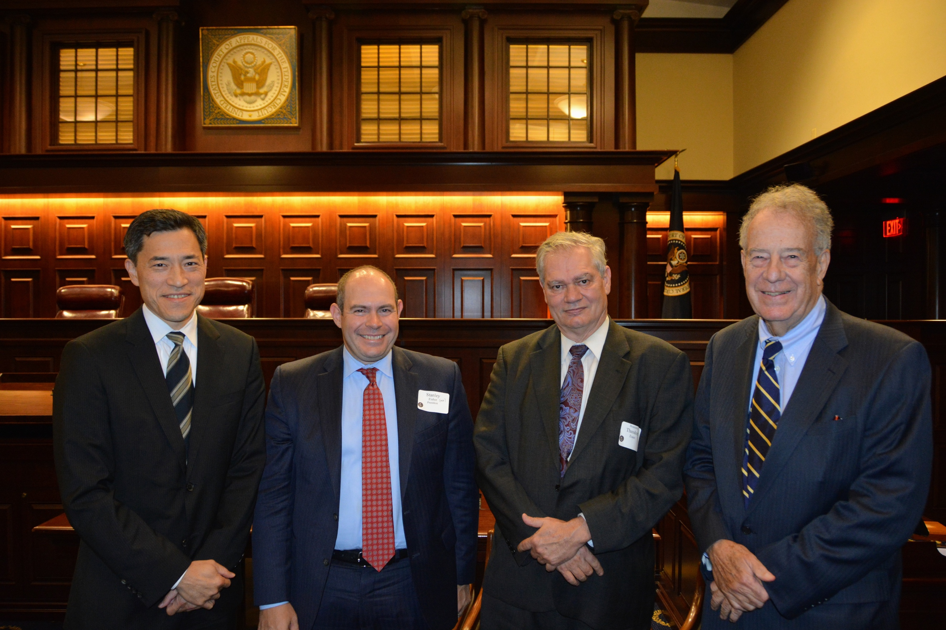
(Current and past Inn Presidents Judge Raymond Chen, Stanley Fisher, ALJ Theodore Essex (Ret.), and Judge Timothy Dyk.)
The program, Issues Arising in Litigation Surrounding Standard Essential Patents, Including FRAND Obligations in the District Courts, the ITC and International Forums, featured a panel discussion moderated by ALJ Theodore Essex (ITC, retired) (Hogan Lovells).
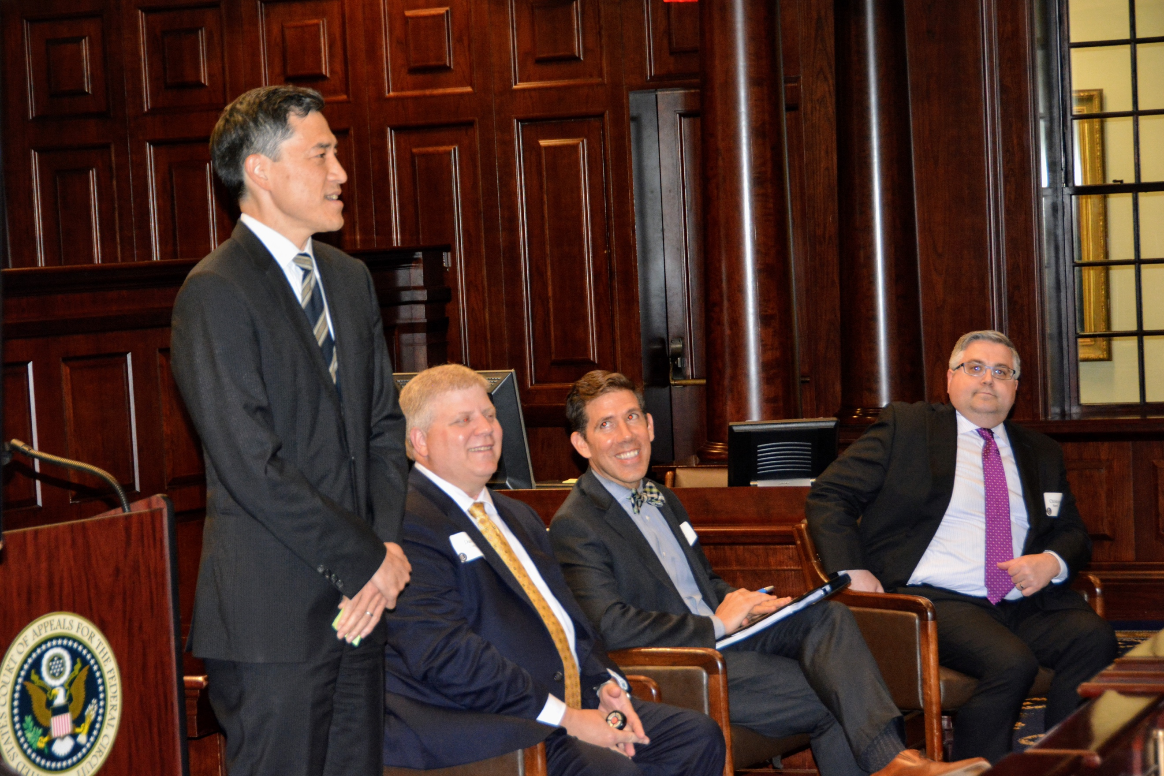
(Inn President Judge Raymond Chen introduces the speakers.)
The panel featured ALJ Clark Cheney (ITC), David Long (Essential Patent LLC), Christopher Burrell (Samsung), and Natalie Bennett (Morgan Lewis). The panel shared their experiences with litigating Standard Essential Patents in District Courts and at the ITC. Christopher Burrell shared his experience as an inside counsel. Natalie Bennett provided a primer on U.S. litigation, and David Long explained other options followed in foreign jurisdictions.
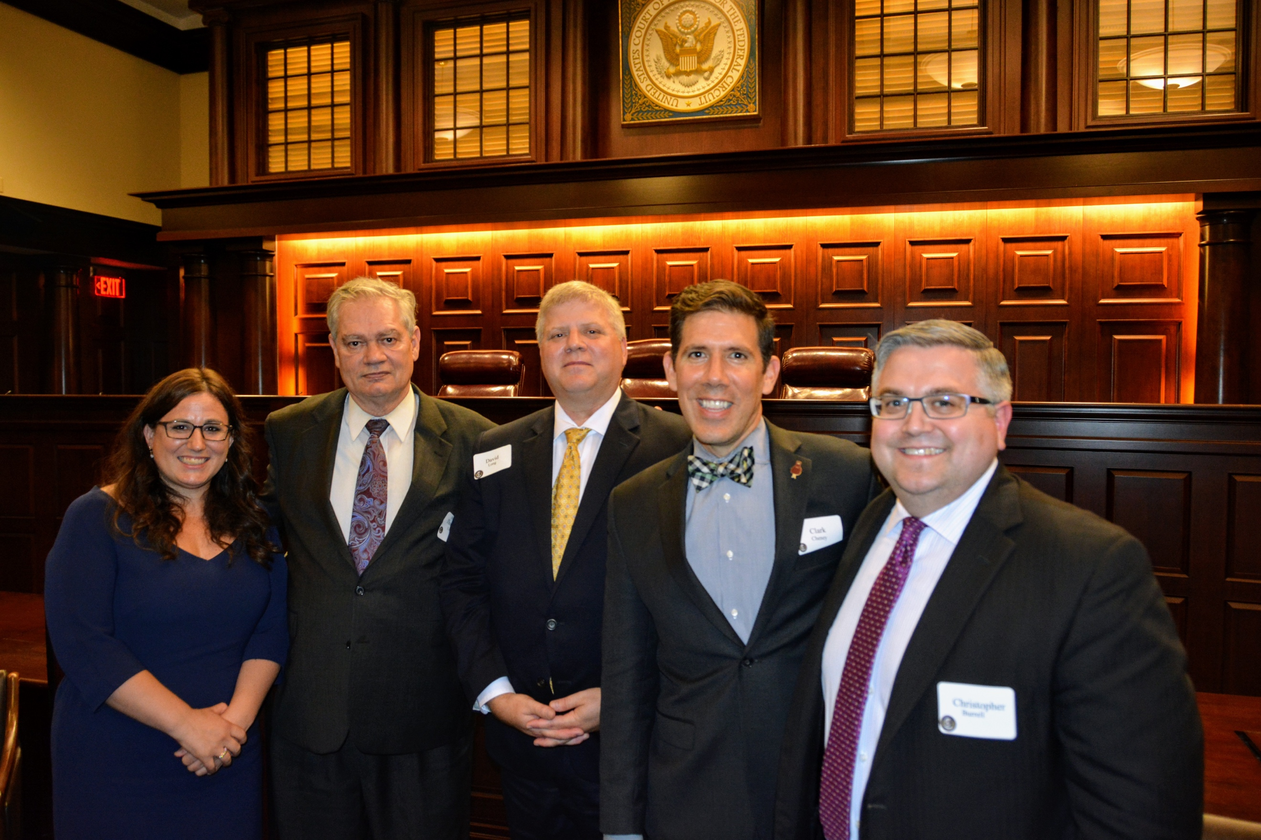
(From left to right: Natalie Bennett, ALJ Theodore Essex (Ret.), David Long, ALJ Clark Cheney, and Christopher Burrell.)
The pre- and post-meeting reception was held in the Dolly Madison House, and was well-attended.
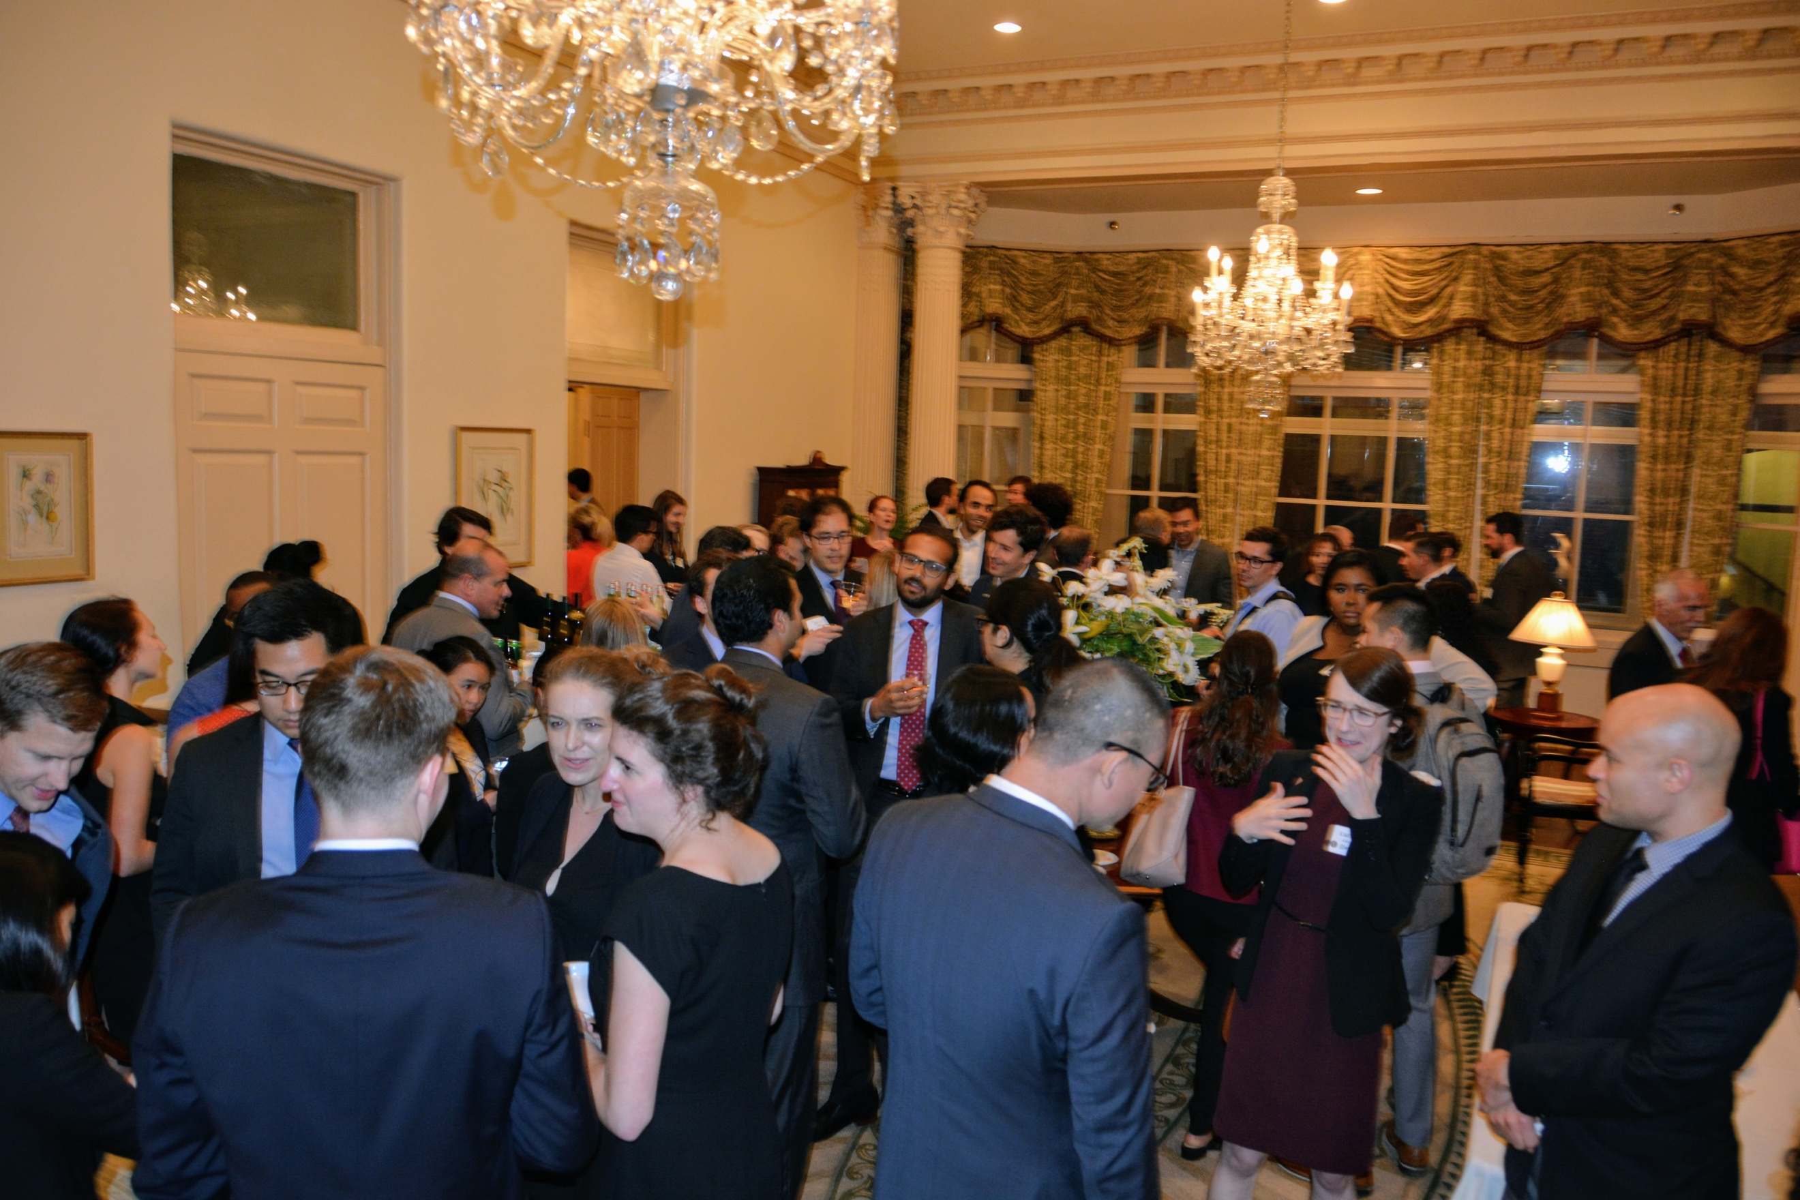
(The event drew an unusually large crowd, both prior to and after the program.)
If there are any questions or concerns, please feel free to reach out to Kiley White at whitek@cafc.uscourts.gov.

