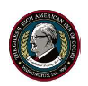 THE GILES S. RICH AMERICAN INN OF COURT
September 26, 2016
Via Electronic Transmission

September 2016 Meeting Recap

On Tuesday, September 13, the Giles S. Rich American Inn of Court kicked off its 25th anniversary season, providing programming, civility, and context from longtime Judge Pauline Newman, who knew Judge Rich well and was kind enough to speak to the assembled Inn.

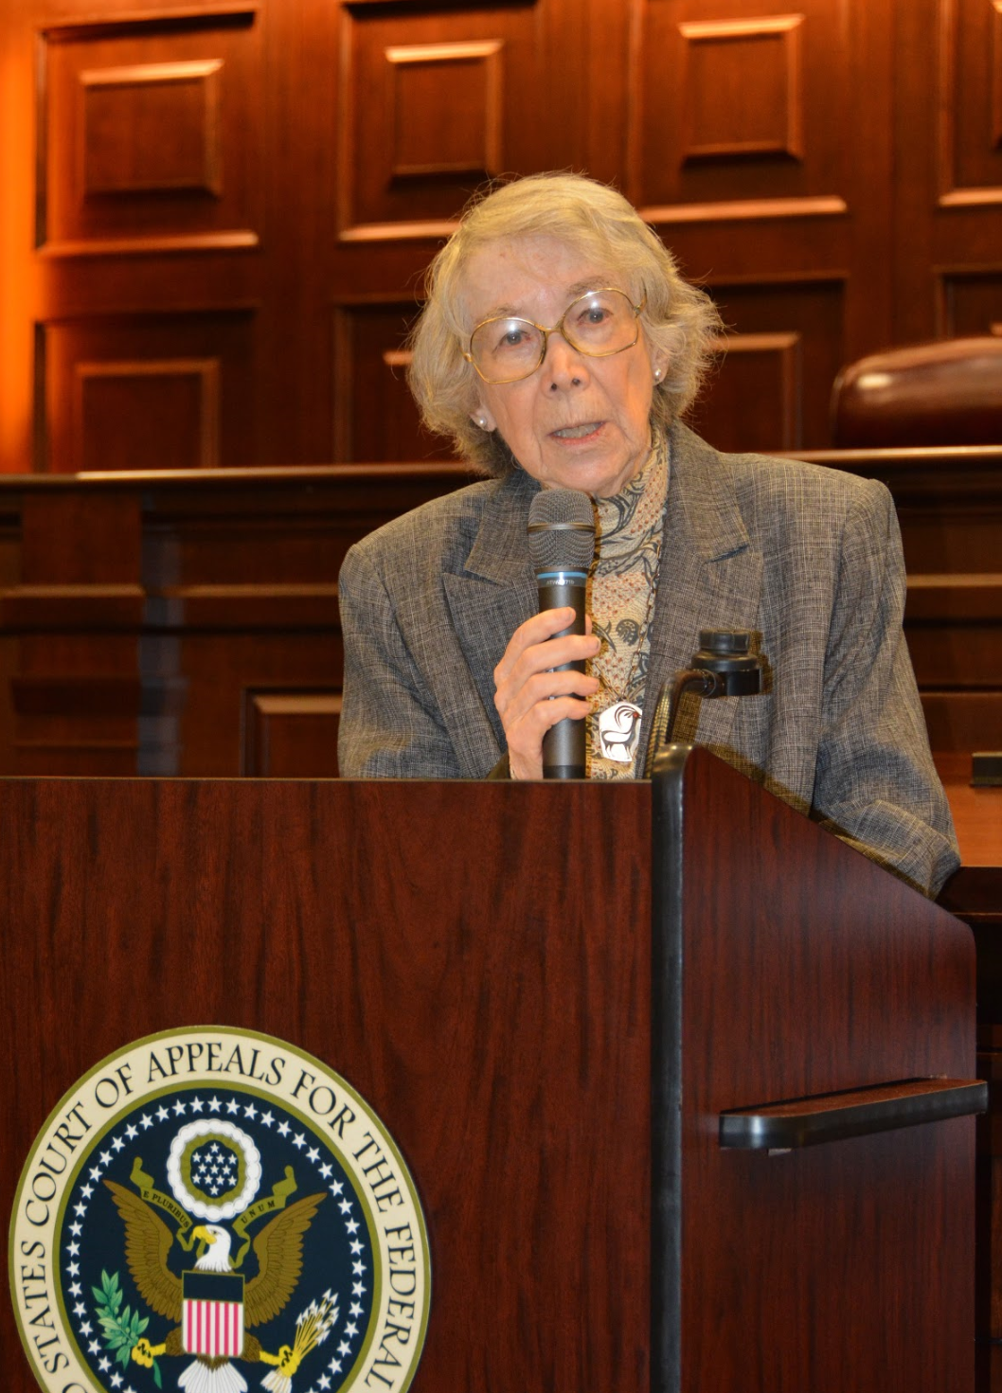 | Inn President Janet Gongola, the Patent Reform Coordinator for the USPTO, began by welcoming the new members, discussing the history and purpose of the Inn, and encouraging them to take advantage of the wonderful mentorship program and other opportunities. She highlighted the many special events and features of this year’s Inn, as we celebrate 25 years of Judge Rich’s legacy, and the long shadow he continues to cast over patent law. She then ceded the majority of her time to Judge Pauline Newman, who provided historical details, color, and a packet of original writings and speeches from the oft-discussed father of the patent bar.
The primary program, a panel discussion of the state of 35 U.S.C. 101 subject-matter eligibility in the wake of the Supreme Court’s decision in CLS Bank v. Alice and “[a]fter Enfish and Bascom,” was moderated by longtime Inn member and current PTAB Judge Bruce Wieder. It featured robust discussion meant to encapsulate the bar’s sentiment that the law of section 101 suffers from uncertainty and inconsistency in the wake of the Supreme Court’s recent decisions. The discussion detailed the varying concerns from the pharmaceutical, high technology, mechanical, government, and legal sectors.

The primary program, a panel discussion of the state of 35 U.S.C. 101 subject-matter eligibility in the wake of the Supreme Court’s decision in CLS Bank v. Alice and “[a]fter Enfish and Bascom,” was moderated by longtime Inn member and current PTAB Judge Bruce Wieder. It featured robust discussion meant to encapsulate the bar’s sentiment that the law of section 101 suffers from uncertainty and inconsistency in the wake of the Supreme Court’s recent decisions. The discussion detailed the varying concerns from the pharmaceutical, high technology, mechanical, government, and legal sectors. | 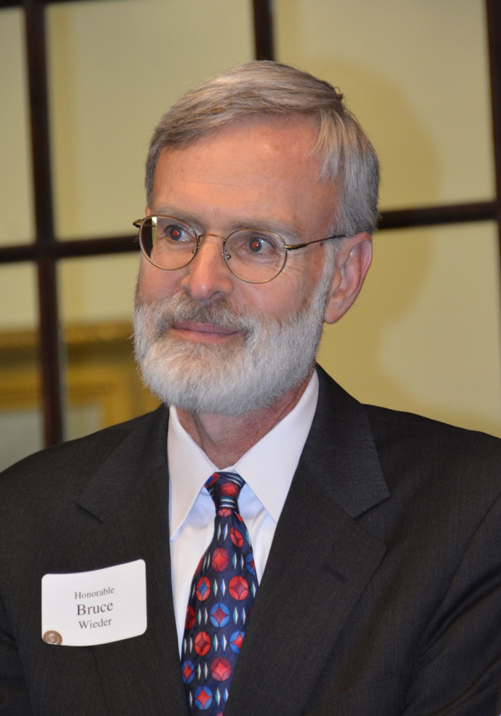

The panel included USPTO Commissioner of Patents Drew Hirschfeld; Suzanne Michel, Senior Patent Counsel at Google, Inc.; Robert “Bob” Armitage, who spent many years as senior vice president and general counsel for Eli Lilly and Company, who was central to drafting the AIA, and who currently lobbies Congress for further reform; and George Washington University Law School Associate Dean for IP John Whealan, a mainstay of the DC patent community and former deputy general counsel and solicitor of the USPTO.

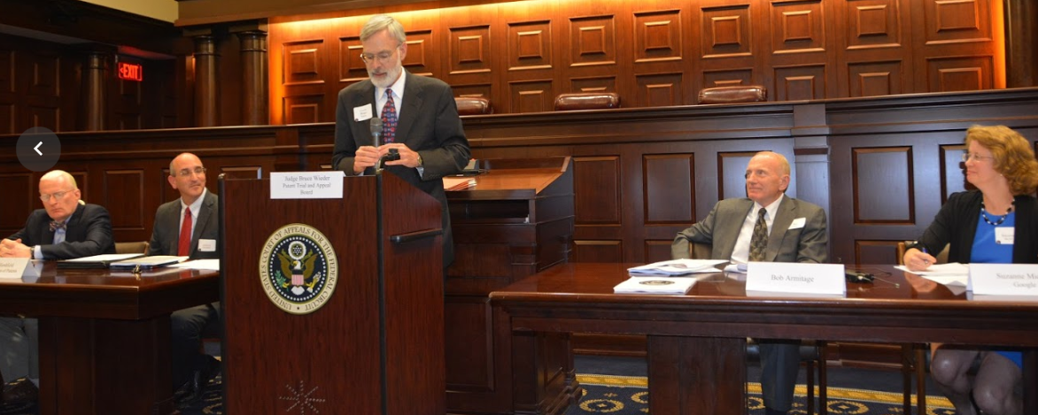

The tone was refreshingly light, curious, and considerate, with the speakers from different sectors wondering aloud whether the law of 101 was yet fully developed, worrying over uncertainty in the legal test and its application, and countering the oft-repeated alarmist tone raised by members of the bar. Speakers noted the more than 325,000 U.S. patents granted in the past two years, but expressed concerns over the use of 101 to hold ineligible patents directed to diagnostic devices, lamenting the fact that the Office of the Solicitor General was not even asked by the Supreme Court to brief the issue in Sequenom v. Ariosa, a recent request for certiorari, before denying cert. Dean Whealan noted that the McRo, Inc. v. Bandai Namco Games America opinion, issued by the Federal Circuit earlier that day, offered another guidepost, and likened the law of 101 to a football field, where the difficulty lies in how close or far from the patent-ineligible end zone concepts any particular invention tends to be. He highlighted, as some courts have, the “directed to” language as requiring a more complete look into what the preamble and the claim as a whole embody. All panelists seemed to agree that legislative changes were, for the time being, unlikely, though all expressed hope that the evolving law of 101 at the Federal Circuit will help shed light on the outer limits of its use.

In sum, Inn members were treated to an in-depth discussion by the very people lobbying for changes and working on ongoing cases in that area, a richly rewarding experience. Following the program, Inn members proceeded to a lively reception at the Dolly Madison House.

The Inn thanks Judge Wieder for taking the reins solo and organizing an informative event. We look forward to seeing members at the October meeting, to be held at the U.S. Court of Appeals for the Federal Circuit on Thursday, October 13, 2016.

The topic will be The PTAB and the Federal Circuit: Appeals Under the AIA, presented by two founding members of the Inn, The Honorable Barry Grossman of the U.S. Patent & Trademark Office; and Don Dunner, of Finnegan, Henderson, Farabow, Garrett & Dunner, LLP. | 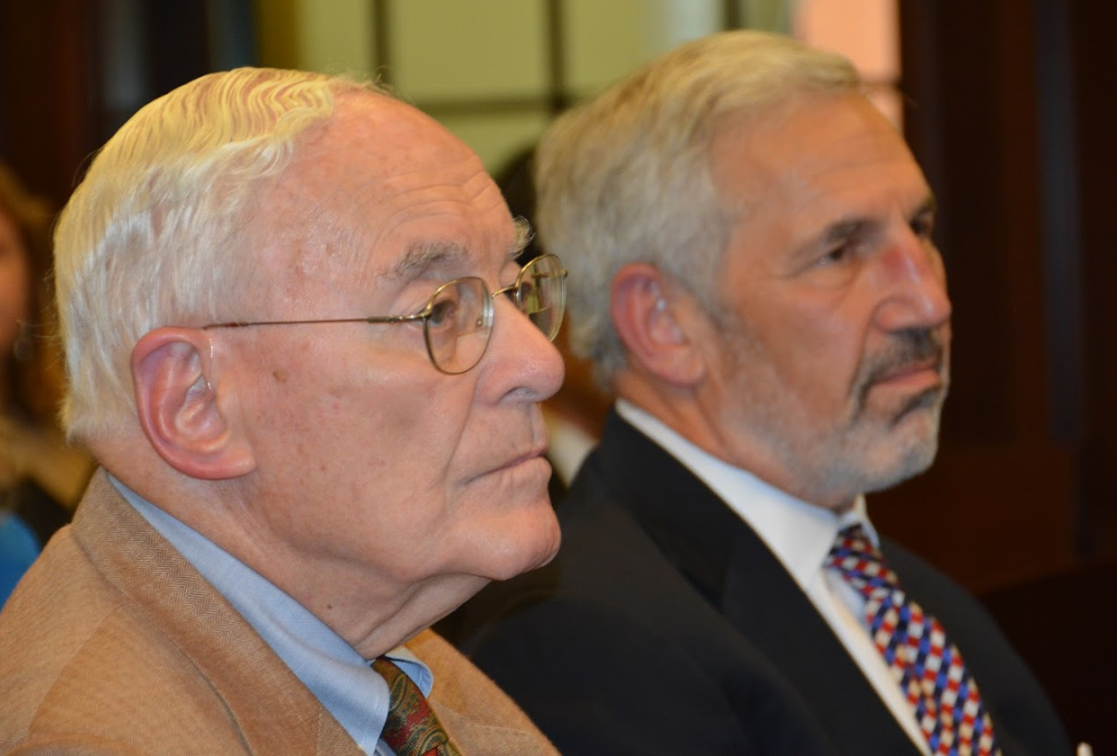

Summary provided by Inn Historian Jonathan Stroud.

For those interested in registering as a mentor, a mentee, or both, please complete the application found at the back of the Handbook, and send it to the mentoring chair, Daniel Kane.

