I’Anson Hoffman

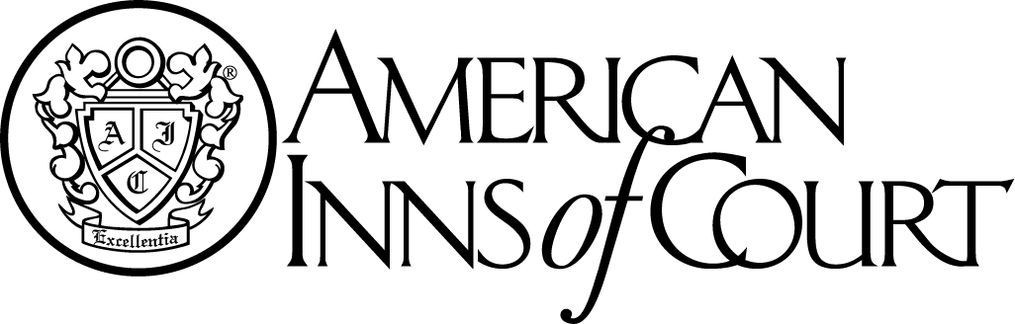

Joint Meeting with the James Kent Inn of Court

**Wednesday, April 13, 2016**

Norfolk Yacht & Country Club

7001 Hampton Blvd.

Norfolk, VA 23505

**Social Hour: 5:30 p.m. – 6:30 p.m.**

**Dinner & Program: 6:30 p.m.**

PROGRAM

The Justice Gap-Access to the Courts

Panel Speakers

Virginia Supreme Court Justice Bernard Goodwin

Karl Doss – Executive Director of the VSB Access to Legal Services Committee

Ray Hartz – Legal Aid of Eastern Virginia

1 Hour CLE

This is a dinner meeting and we cannot accept late RSVPs for dinner. Please RSVP no later than **noon, April 3, 2016** to: iansonhoffmaninnofcourt@gmail.com