I’Anson Hoffman

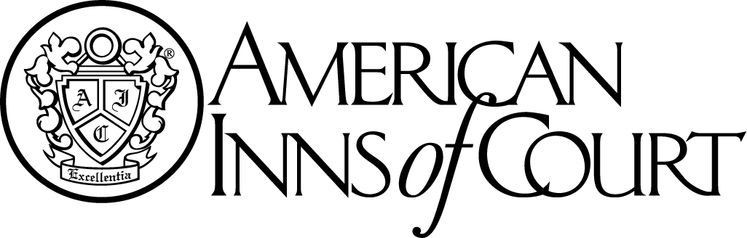

**Meeting Notice**

**February 10, 2016**

Norfolk Yacht & Country Club

7001 Hampton Blvd.

Norfolk, VA 23505

**Cocktails – 5:30 p.m.**

**Dinner and Program: 6:30 p.m.**

Presentation By Pupilage Group VI

Toastmaster: Elizabeth Bircher

Please RSVP by **COB, February 3, 2016** to:

iansonhoffmaninnofcourt@gmail.com