NEXT MEETING

Wednesday, January 13, 2016

5:30 - Cocktails
6:30 – Dinner and Program

Hampton Yacht Club

NOVEMBER MEETING RECAP
The members of the Inn gathered for the November meeting at the Norfolk Yacht and Country Club on November 4, 2015. Pupilage Group II entertained the members of the Inn with short vignettes regarding timely ethical concerns, using examples of where attorneys found themselves facing discipline from the Virginia State Bar.
A number of interesting ethical questions were raised, including actual signature requirements on electronically filed documents, unsubstantiated charges brought by a prosecutor (and the distinction between a violation of the ethical rules and incompetence), and the consequences of some very questionable conduct on the part of an attorney representing himself in a divorce.

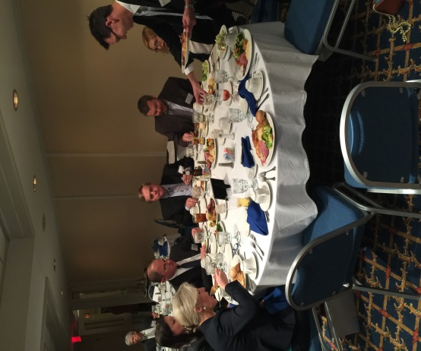

TOASTING TORCH
Bonnie Lane passed the toasting torch to Kevin Duffan, who will be providing the traditional toast to begin the evening at the January meeting.

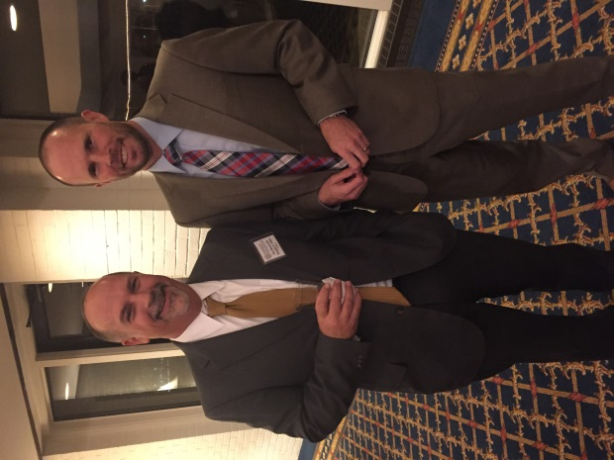

.

UPCOMING PROGRAM
Pupilage Group IV will be presenting at the next meeting at the Hampton Yacht Club.
Happy holidays!
Until next issue . . .
Elaine Hogan
Newsletter Editor

