NEXT MEETING
Wednesday, November 4, 2015

5:30 - Cocktails
6:30 – Dinner and Program

Norfolk Yacht & Country Club

OCTOBER MEETING RECAP
The Inn’s first meeting of the 2015-2016 year was held in Williamsburg at William & Mary Law School on October 7, 2015. The Inn welcomed its new members with an orientation and then all members were given the opportunity to socialize over cocktails and hors d’oeuvres prior to the evening’s main event.
Jeffrey Bellin, a professor at William & Mary Law School with a particular focus and expertise in evidentiary matters, provided the Inn with an interesting presentation regarding the comparison between the Virginia Rules of Evidence and the Federal Rules of Evidence.

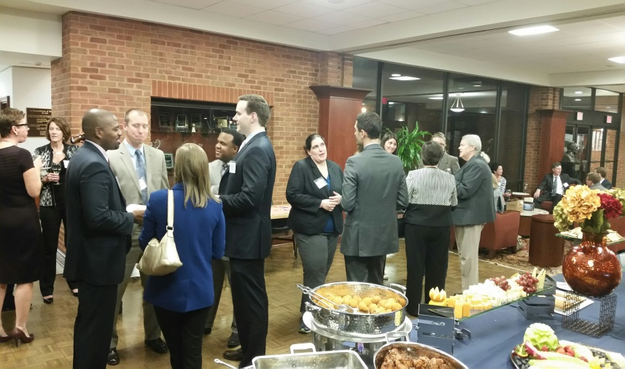

TOASTING TORCH
Bonnie Lane will be providing the traditional toast to begin the evening at the November meeting.

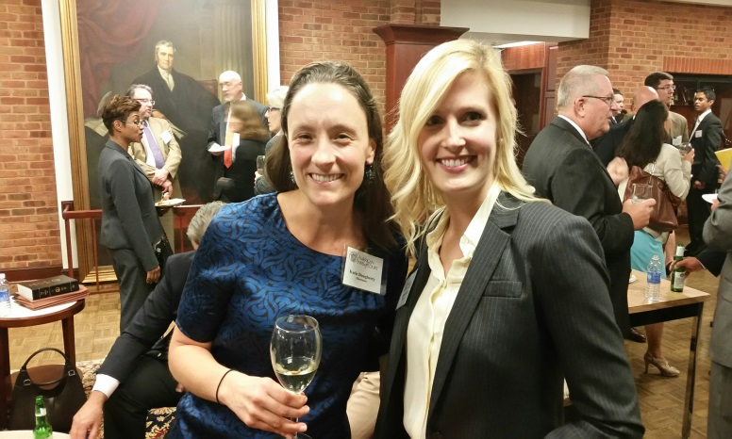

MENTORS/MENTEES
All mentors are encouraged to get in contact with their mentees. Pictured above—Mentor Katie Dougherty and her Mentee Elizabeth Hill at the October meeting.

UPCOMING PROGRAM
Pupilage Group II will be presenting at the next meeting at the Norfolk Yacht Club.
Until next issue . . .
Elaine Hogan
Newsletter Editor

