I’Anson Hoffman

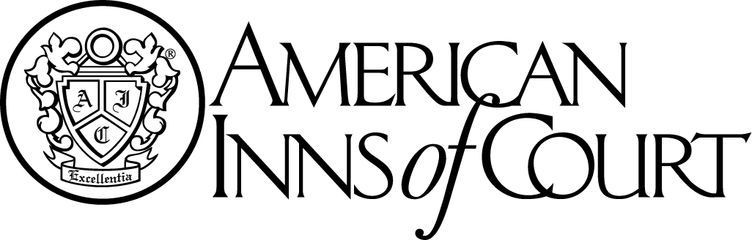

**Meeting Notice**

**November 4, 2015**

Norfolk Yacht & Country Club

7001 Hampton Blvd.

Norfolk, VA 23505

**Cocktails – 5:30 p.m.**

**Dinner and Program: 6:30 p.m.**

Presentation By Pupilage Group II

Toastmaster:

Please RSVP by **October 29, 2015** to:

iansonhoffmaninnofcourt@gmail.com