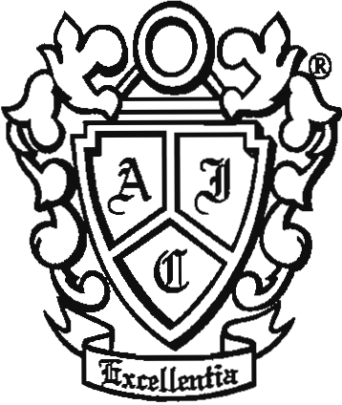

Executive Committee

President
Honorable James C. Lewis

Vice President
Honorable Douglas E. Miller

Treasurer
Larry M. Dash, Esq.

Secretary
Polly Chong, Esq.
Immediate Past President
Honorable Colleen K. Killilea.

Directors:

Christian L. Connell, Esq.
L. Steven Emmert, Esq.
Honorable Mary Jane Hall
Sandra L. Smith, Esq.
W. Ryan Snow, Esq.
IʹANSON-HOFFMAN AMERICAN INN OF COURT XXVII

Orientation Agenda
October 7, 2015 @ 5:30 PM
William & Mary School of Law

- Welcome
The Honorable Colleen K Killilea,
Immediate Past President
(or the Honorable James C. Lewis if available)

- History of The I’Anson Hoffman Inn of Court
W. Ryan Snow

- Mission and Structure, including Member Obligations, such as Dues, Attendance, and Participation
Polly Chong

- Importance of Pupilage Groups and Programs
Larry M. Dash , Treasurer
L. Steven Emmert, Programs Chair

- Mentor Program
Sandra L. Smith

- Conclusion
- Community Outreach
- Achieving Excellence Program
The Honorable Colleen K. Killilea

