I’Anson Hoffman

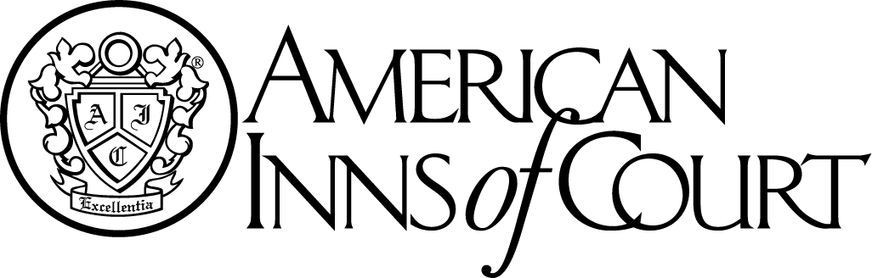

**Meeting Notice**

**October 7, 2015**

William & Mary School of Law

**New Member Orientation – 5:30 PM**

**Cocktails & Hors d’oeuvres - 6:00 p.m.**

**Program: 7:00 p.m.**

Presentation By: Professor Jeffrey Bellin who will provide a CLE presentation on the Federal Rules of Evidence.

Toastmaster:

Please RSVP by **noon, October 1, 2015** to:

iansonhoffmaninnofcourt@gmail.com