MAY MEETING RECAP
In keeping with tradition, the final meeting of the year was held in Williamsburg on May 6, 2015. Members of the Inn were fortunate enough to hear from Magistrate Judge Tommy Miller while enjoying a delicious meal in the beautiful setting of Wren Hall.
On behalf of the members of the Inn, Polly Chong presented a gift to Judge Killilea to thank her for her contributions to the Inn as President.
The Inn elected the following new officers and board members for the upcoming year:
Officers

President: Hon. James C. Lewis
Vice President: Hon. Douglas Miller
Treasurer: Larry Dash
Secretary: Polly Chong
Immediate Past President. Hon. Colleen Killilea
Board Members

L. Steven Emmert
Hon. Mary Jane Hall
Sandra Smith
W. Ryan Snow
Christian Connell
The Executive Committee is hard at work planning the upcoming year and will provide more information shortly.

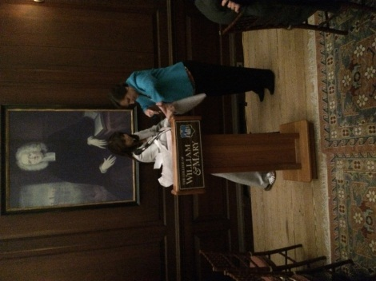

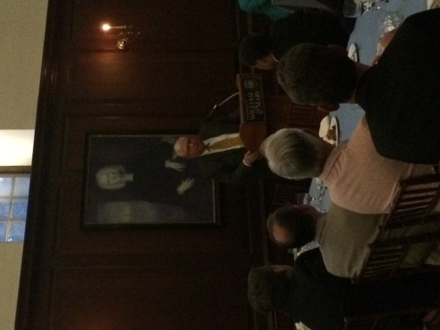

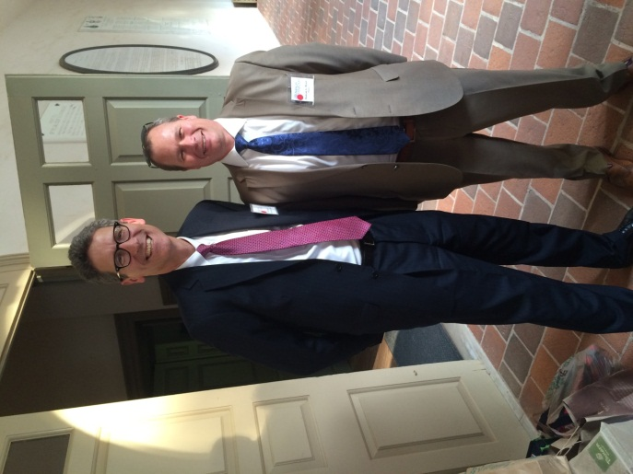

The Inn’s annual picnic will be in September. More details will follow.
I hope everyone is enjoying the summer.
Until next issue . . .
Elaine Hogan
Newsletter Editor

