Introduction
Reference: I.R.C. section 6531

The statute of limitations on criminal prosecutions under the tax code is found in section 6531. The statute provides for a limitation of 3 years on bringing an indictment against a person. However, this general rule is more or less subsumed by a list of eight offenses for which the limitations period is 6 years. These are:
- Defrauding the United States or one of its agencies in any manner (including conspiring to defraud, attempting to defraud, and impeding, impairing, obstructing and defeating the lawful functions of the IRS).
- Willfully attempting in any manner to evade or defeat any tax or tax payment.
- Willfully aiding or assisting in, or procuring, counseling, or advising, the preparation or presentation under, or in connection with any matter arising under, the internal revenue laws, of a false or fraudulent return, affidavit, claim, or document (whether or not such falsity or fraud is with the knowledge or consent of the person authorized or required to present such return, affidavit, claim, or document).
- Willfully failing to pay any tax or make any return (other than an information return) on time.
- Willfully making or signing false documents under penalty of perjury, or giving the IRS a fraudulent or false return, statement, or other document.
- Corruptly or forcibly interfering with the due administration of the tax laws.
- Certain offenses committed by U.S. officers or agents (i.e.: official corruption).
- Offenses arising under the general federal conspiracy statute, where the object of the conspiracy is to attempt in any manner to evade or defeat any tax or tax payment.

FROM DOJ Criminal Tax Manual:

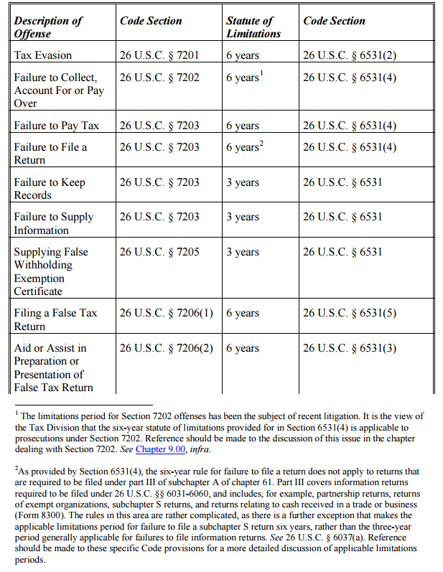

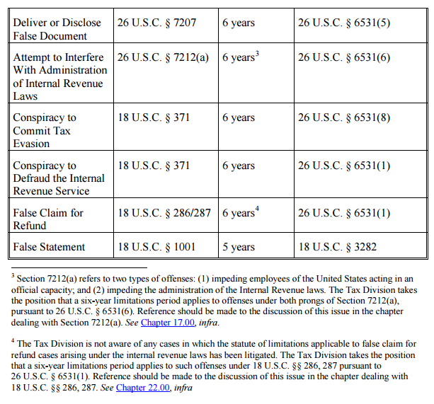

Sneaky Tax Protestor
Case Reference: United States v. Halbig, 390 U.S. 222 (1968).

Attorney: John, it seems you have a bit of a problem.

John: How do you mean?

Attorney: Well, how can I break it to you? You’ve been charged by the U.S. government with attempting to evade taxes by filing of a false return and aiding in the preparation and presentation of a false return.

John: So?

Attorney: Um. You can go to jail if convicted.

John: But the income tax isn’t even legal, so what’s the big deal? The Sixteenth Amendment was never properly ratified, you know. And—and!—I’m outside the statute of limitations anyway. It’s been well over three years since I filed that return, so I’m good.

Attorney: *shaking head* I can’t even— Just, don’t say anything about the Sixteenth Amendment in court. On the statute of limitations, you’re in trouble. The Code does say it’s three years, but there are a number of exceptions which extend the limitations period to six years. Basically, the exceptions swallow the rule, and your indictment is under those exceptions.

John: Whatever. They can’t do anything to me. I’m a sovereign citizen.

Attorney: Now, listen. Your indictment was filed today, that’s March 10th. You’d filed those dodgy tax returns on March 10th and March 13th, 2009. Pretty much six years ago to the date.

John: *laughs* And, boy, did I get them good! Those returns were due in 2008, and I got an extension! Or two…

Attorney: But—

John: Say, doesn’t that put me outside the statute? It’s been more than 6 years. They can’t touch me!

Attorney: Well, not exactly. I mean, the government cut it close, but they got the cigar. Your crimes—um, your alleged crimes—were committed when you filed the return.

John: Now, hold on. I Googled this stuff earlier. The statute of limitations—what is it, 6351?

Attorney: 6531…

John: Right, whatever. So it says that you have to look at the rules in section 5613—

Attorney: 6513…

John: Yeah, I’m talking. Anyway, the rules of section 1653—

Attorney: *rolls eyes*

John: *looks pointedly at Attorney* —say that—*ruffles papers*—“the last day prescribed for filing the return or paying the tax shall be determined without regard to any extension of time granted the taxpayer.” So the statute begins to run with the original due date of the return, April 15, 2009. I win.

Attorney: Nice try, but that rule only applies when a return is filed before it is due. When that happens, the period of limitations begins to run on the due date. But if you file the return after it is due, the statute begins to run when the return is actually filed.

John: That’s stupid. Says who?

Attorney: A group of nice men in black robes called the Supreme Court, in 1968.

John: So the indictment is effective?

Attorney: Yes.

John: Can you get me out of the country?

[END]

Dastardly High-Roller
Case Reference: Jaben v. United States, 381 U.S. 214 (1965); United States v. Yip, 248 F. Supp. 2d 970 (D. Haw. 2003); United States v. Bardina, 365 F. Supp. 459 (S.D.N.Y. 1973).

Junior Federal Prosecutor: Sir, we finally have enough evidence to put Mr. Fatcat away. The other guys couldn’t get him on all his alleged crimes and crooked financial dealings, but we’ve pretty much got him on falsely understating his income. We’ll be ready to file a complaint charging the crime within a month.

Senior Federal Prosecutor: Great! How long have we been tracking him?

Junior: Years and years.

Senior: Yes, quite, quite. How many exactly?

Junior: Oh, seven or eight. Since long before I joined up.

Senior: Are we fine on the statute of limitations?

Junior: *blanching* I’m…not sure.

Senior: Let me see the case file. *ruffles papers* The statute of limitations on false returns is six years, you know. *more ruffling* There we are. He filed the return on April 1st, 2007, so the statute began to run two weeks later, when the return was due to be filed. Today is March 10th, so we’re almost eight years away

Junior: Does this mean he’ll get away scot free?

Senior: Not necessarily. See, he’s been out of the country quite a bit. The statute is tolled when he is outside the United States or a fugitive from justice. *brief pause, Senior looking at paper* Looks like Mr. Fatcat has been enjoying the worldly pleasures of the Mediterranean and Caribbean quite a bit. A year’s stay on Malta and a year on Dominica. Which means you’ve got until April 15th to get him charged.

Junior: But he also spent a year on Puerto Rico, and the Code specifies that the “United States” means only the states and D.C. Doesn’t this give us an extra year to get the indictment?

Senior: There was a case some years back, when I was a young lad. Bardeña…no! Bardina it was. It held that U.S. possessions, and Puerto Rico in particular, are considered part of the United States for purposes of tolling the statute of limitations. Sorry, Junior, you’ve only got until April 15th.

Junior: But, sir, we’re grossly understaffed right now. We won’t be able to get an indictment issued so quickly!

Senior: Relax, Junior. As long as you file the complaint before mid-April, you’ll get the statute of limitations extended by another nine months. That should be enough time.

Junior: Good! It’ll be a relief to get this dastardly high-roller put away.

Senior: That it will, that it will.

[END]

