Tampa American Inns of Court

information & membership Application

The AmericAn inns of courT TAmpA chApTers
inviTe you To Apply for membership.
The American Inns of Court is a national organization designed to improve the skills, professionalism, and ethics of the bench and bar. Tampa’s civil litigation Inns are The J. Clifford Cheatwood Inn, The
Ferguson-White Inn, The Tampa Bay Inn, and The Wm. Reece Smith Litigation Inn. Each Inn limits membership to approximately 80 members who are assigned to pupillage groups of eight or nine members. Pupillage groups include at least one judge as well as attorneys of varying experience and areas of practice. The Inns usually meet monthly from September through May for dinner programs, except for The Wm. Reece Smith Litigation Inn which meets monthly for a weekday luncheon. Inn members usually earn one hour of CLE credit for each program attended.
Each year, the Inns invite new members to join for varying membership terms. Members are selected based upon their length and area of practice. Discounted memberships are available for full-time law students who wish to apply. If you are interested, please apply promptly! (Please note: Current Inn members who wish to renew membership in their present Inn need not apply.)

Name: Firm: Address: Email address: Years in practice and specialty? Prior experience with any Inn of Court? Have you previously applied? When? Have you been referred to an Inn? If so, by whom? List any weekday evening you cannot attend meetings:

Do you have a preference for a particular Inn?
Ferguson White Inn

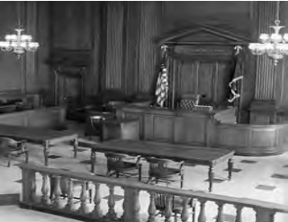
Please attach a current resume limited to one page in length.

