Mark F. Baseman Awarded Theodore Millison Professionalism Award

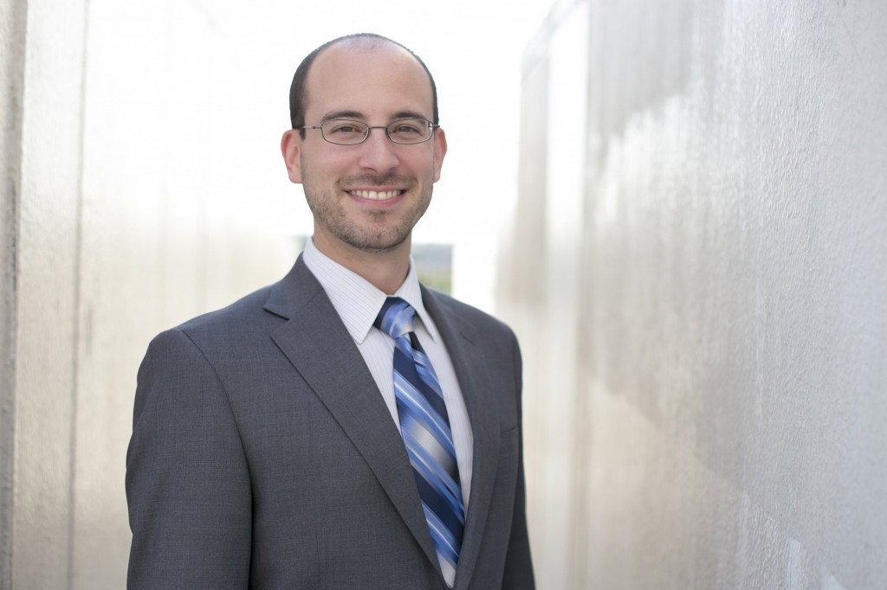
Mark F. Baseman was awarded the 2022 Theodore Millison Professionalism Award by the Stann Givens American Family Law Inn of Court of Tampa. The Theodore Millison Professionalism Award, named in honor of the late Theodore Millison, a Tampa family law practitioner who was beloved in the family law community, is given once a year to an attorney who exemplifies the highest standards of ethics and professionalism in the practice of family law. This is the highest award presented by the Stann Givens Family Law Inn of Court.
Mark’s peers chose him for this award in part because he is so generous with his time in assisting Inn members and attorneys across the state of Florida with appellate issues. He is an incredibly talented appellate attorney, and maintains the professional standards of ethics in every situation, from the initial evaluation all the way through oral argument. He is also incredibly personable with a fun sense of humor, which has endeared him to both his peers and his clients.
After graduating from Temple University, Beasley School of Law, Mark practiced as a family law litigator, eventually moving to family law appellate work as a partner at Felix, Felix & Baseman, LLC.
The award was presented to Mark at the April 6, 2022 Inn of Court meeting. On June 30, 2022, the ceremony dedicating the courthouse plaque was held at Hillsborough's George Edgecomb Courthouse. Mark was joined in this celebration by his family, peers, colleagues and several members of the judiciary. Following the ceremony, Mark unveiled the new plaque permanently located on the 4th floor of the courthouse.

