2021-2023 Fact Pattern

Aw Shoot!

- Variety article
- Enlarged photo
- Incognito Rendering
- Recommended background reading

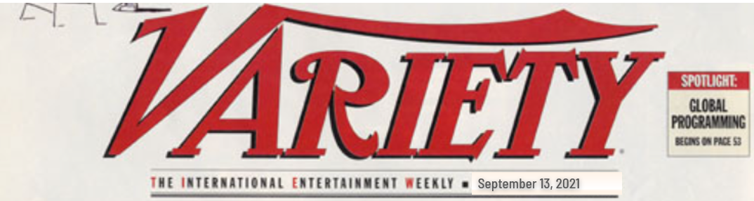
PHOTO CO. AIMS TO K.O. KUNA IN COURT ON COPYRIGHT
Popular Singer-Model Likely To Punch Back On Publicity, Trademark & Other Claims ⁓Posed Pic And Circumstances of Creation At Heart Of Dispute
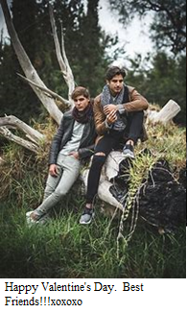

On July 5, 2021, Eastman Surveillance, Inc., (ESI) filed a lawsuit against Trey Kuna and Guy Incognito in a New Jersey federal district court. The Los Angeles based professional photography business claims that Kuna, the internationally known Croatian-born singer and model whose real name is Marko Knežević, III, and Incognito, a long-time sidekick, made improper use of a photo of the two of them to which ESI held the intellectual property rights. Kuna currently lives on an estate in New Jersey, and Incognito reportedly inhabits a bedroom loft atop the free-standing recording studio and media center building in a converted barn on the property.

Kuna is a well-known model, actor, and singer. After gaining popularity as a model and actor who appeared in various television shows, movies, and advertisements, Kuna signed with Geffen Records in 2014.

The photo (right) was apparently taken by Bonnie Infared (B.I.) Focal, an independent contractor with some relation

to ESI. The Complaint further alleges that the photographer assigned her rights to the company, and that ESI filed for copyright registration on February 15, 2020 and posted thumbnails of it in the ESI on-line
catalogue shortly thereafter. ESI, owned by Flip Tripod, is a professional photography business founded in 2010 that has grown to employ over three dozen photographers, who generate tens of thousands of photographs available for license each year. ESI’s catalog contains an incredible quantity of photographs of Kuna and other stars, many of which are accompanied by United States Copyright Registration information.

The Hollywood elite has referred to ESI as “paparazzi” and “scourge of the earth,” though some artists seem to enjoy the extra attention. Though the ESI website does advertise its photos for licensed use by newspapers and other news media (and to commercial advertisers), it also advertises and sells framed prints to fans and other members of the public, sometimes offering “limited editions” with promises that only a certain number of such prints will be made. The “Best Friends” photo and others featuring Kuna were made available for such purchase, and were periodically advertised by ESI with hashtags such as “#Tr(e)yKunaPrintsFromESI” and “#MostNewsworthySightingsOfMostPopularSingerModel.” The posting noted beneath such hashtags that there were pictures and poses available from ESI that “you can’t get from Kuna or singermodel.com’s fan store.”

The complaint further alleges that Kuna began posting the photo on February 14, 2020, the day before the federal registration. According to the complaint, on February 14, 2020, Kuna uploaded a picture of himself and his high school friend Guy Incognito (seated with the ripped jeans) to his Instagram, Snapchat, Facebook, Tik Tok, and at his website singermodel.com. The picture was captioned “Happy Valentine’s Day! Best friends!!!xoxoxo” The picture featured Trey and Guy sitting on some fauna, taken while they were walking through a park. It appears the two subjects were posing for the camera. The date and location of the photograph are not mentioned in the complaint, nor is the date of the alleged assignment noted; no written assignment is attached as an exhibit. The feedback from posting the picture was so popular, and Kuna reposted the picture to all of his social media feeds on February 14, 2021. Incognito shared the picture on his social media on the same dates, but did so by linking to the Kuna postings in 2020, and the ESI catalogue in 2021. Unlike the large following of fans and media on Kuna’s social media accounts, Incognito’s social media followers are relatively few in number and appear to be limited to friends, family and acquaintances. The complaint does not state where or how Kuna came into possession of a copy of the photograph to begin with.

ESI posted the complaint on its own website and on several social media accounts, describing complaint as copyright infringement against Kuna and Incognito for copying, storing, and displaying the photograph without license or permission and seeks damages for both the publication on February 14, 2020 and February 14, 2021. ESI further alleges that all conduct evinced on the social media feeds was willful and conducted by Kuna and Incognito themselves. ESI also initiated a PR campaign against Kuna and his website, naming Kuna and his website as infringers across several social media accounts on the internet, publishing several singermodel.com screen shots and using hashtags #singermodel, #singermodel.com-steals, #singermodelinfringes, and #singermodel.com-pirates to draw attention to the ESI postings on their own website and social media accounts.

Kuna is a record-breaking musician. His much-anticipated 2017 debut album titled “Look, I Can Sing Too!” peaked at number three on the charts and yielded 7 singles, including “Everyone Loves Me Except the IRS,” “Buy My Merchandise,” and the smash hit “Listen to Me, I’m So Pretty” which barreled all the way to number one. The album was certified platinum and blazed the trail for Kuna to win Best Breakthrough Artist at the 2018 NRMTV Music Awards. His follow-up album, “You Will Love Me Even More Tomorrow” garnered six Grammy nominations.

Like all stars these days, Kuna maintains an active social media presence. But Kuna is different (and more exciting) because he manages his own social media postings. He came out swinging—and reposted a version of the photo copied from the publicly-filed complaint. He promised counterclaims based on his own alleged ownership of, or at least freedom to use, the photograph as a willing participant in the photographs and as a subject of great interest to many people worldwide. Kuna said “I control my image and likeness, and Focal understood that. – if anyone knows how to sell an image, a look, it’s Trey Kuna.” Also, Kuna said “The photo is worthless without my face, my presence, and I set and posed us for the shot. Geez, Focal was just walking her dog.” Reportedly, Focal used another dog walker’s cell phone to take the shot, who air dropped Kuna and Focal copies. Kuna also challenged ESI’s repeated use of his name, image and singermodel.com trademark to draw attention to ESI and its catalogue. When ESI was contacted for comment, it responded that it would address such claims in litigation if ever made, and that “Everything ESI has done was a legal use of our copyrighted property or legally protected fair use and fair comment under intellectual property law and the first amendment as journalists. References to the generic identifier “singermodel” are non-infringing and non-trademark uses to identify where Kuna’s infringements occurred.”

Guy Incognito did not respond to requests for comment, but linked to and reposted/retweeted Kuna’s posting, adding cryptically to one the comments “With friends like these…” and “what would Kato K do?” He also then posted an altered version of the photo to his and Kuna’s social media accounts in support of a request for contributions to a defense fund. (right). ESI could not be reached for comment as to whether it would challenge use of this altered photo in any amended complaint or whether it anticipated Incognito making affirmative claims against any of the parties to the case.

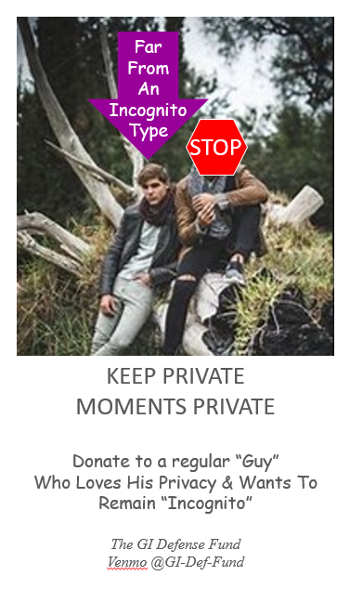

2. Enlarged Photo
Enlarged Photo

3. Incognito Rendering
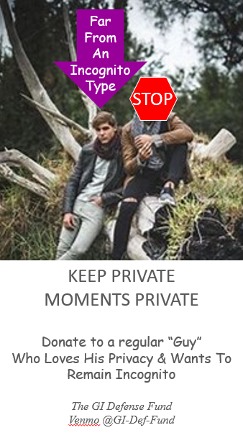

3. Suggested Reading:

TRO/Preliminary injunction Standards

- Ferring Pharm., Inc. v. Watson Pharm., Inc., 765 F. 3d 205, 210-220 (3rd Circuit 2014) (discussing standards for preliminary injunction in false advertising and trademark infringement cases)
- 15 U.S.C. § 1116(a) (Under the Trademark Modernization Act of 2020, a party seeking an injunction is entitled to "a rebuttable presumption of irreparable harm . . . upon a finding of likelihood of success on the merits.")
- TD BANK NA v. Hill, 928 F. 3d 259 (3d Circuit 2019) (irreparable harm in a copyright case)
- Newborn Bros. Co., Inc. v. Albion Engineering Co., 481 F. Supp. 3d 312 (D. New Jersey 2020) (irreparable harm in a false advertising case)
Substantive

- Photographic Illustrators Corporation v. Orgill, Inc. et at., 953 F.3d 56 (1st Cir. 2020) (setting forth the factors involved with copyright licensing, including implied licenses).

- Arrowpoint Capital Corp. v. Arrowpoint Asset Mgmt., 793 F. 3d 313, 319 (3rd Cir. 2015) (setting forth the factors the Third Circuit uses to determine likelihood of confusion).

- United States Patent and Trademark Office v. Booking.com B.V., 591 U.S. __, (June 30, 2020) (A term styled “generic.com” is a generic name for a class of goods or services only if the term has that meaning to consumers.)

- Andy Warhol Found. For Visual Arts v. Goldsmith, ____ F.3d _____ (2d Cir. August 24, 2021), withdrawing and replacing 992 F. 3d 99 (2nd Cir. March 26, 2021) (copyright fair use)

- Google LLC v. Oracle America, Inc., 141 S. Ct. 1183 (2021)(copyright fair use)

- Facenda v. NFL Films, Inc., 542 F. 3d 1007 (3rd Circuit 2008) (right of publicity)

