MATTHEW ROBINSON

Matthew Robinson is a third year student at Columbia Law School. He is a member of the Mediation Clinic and the Black Law Students Association. He also serves as a Diversity Editor on the Columbia Law Review.

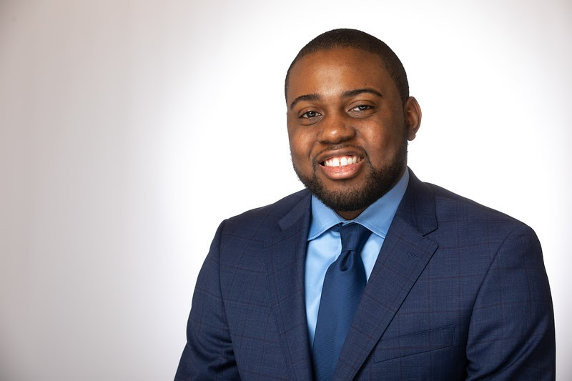

ERICA ZOU

Erica Zou is a third year student at Columbia Law School. She is a member of the Mediation Clinic and the Asian Pacific American Law Students Association. She is also the Public Affairs Editor for the Columbia Journal of Transnational Law.

JEEYOON CHUNG

Jeeyoon Chung is a third year student at Columbia Law School. She is a member of the Mediation Clinic and the Asian Pacific American Law Students Association. She is also the Development and Diversity Editor for the Columbia Law Review.

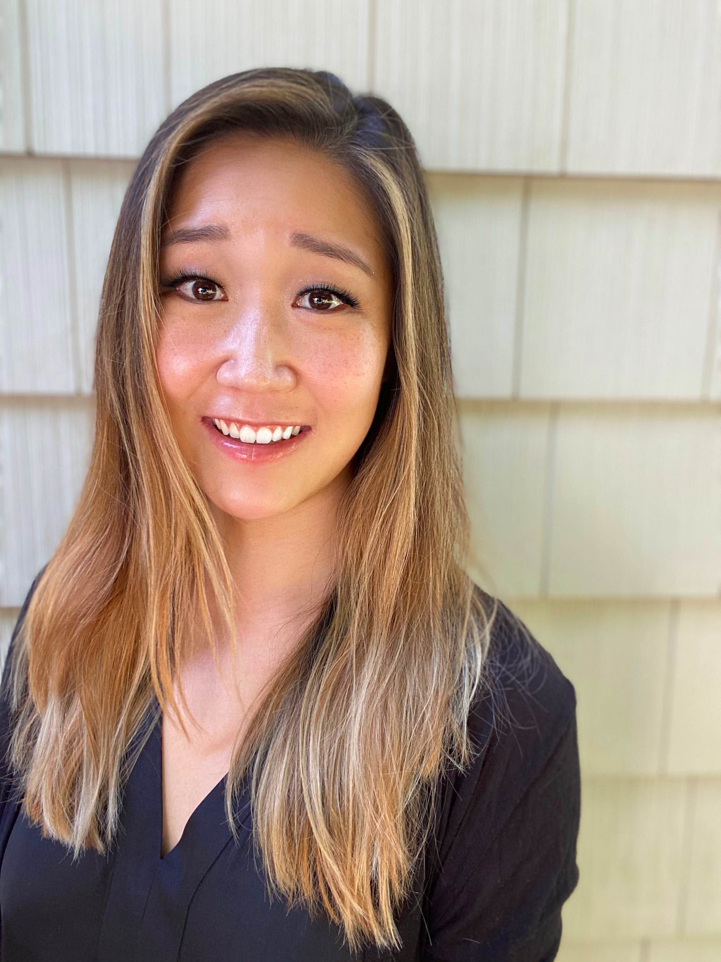

OLIVER KWON

Oliver Kwon is a third year student at Columbia Law School. He is a member of the Mediation Clinic, the Real Estate Law Society, and the Asian Pacific American Law Students Association.

CORY STEINBERG

J. Cory Steinberg is a third year student at Columbia Law School. He is a member of the Mediation Clinic, the Business and Law Association, and the Entertainment, Arts, and Sports Law Society.

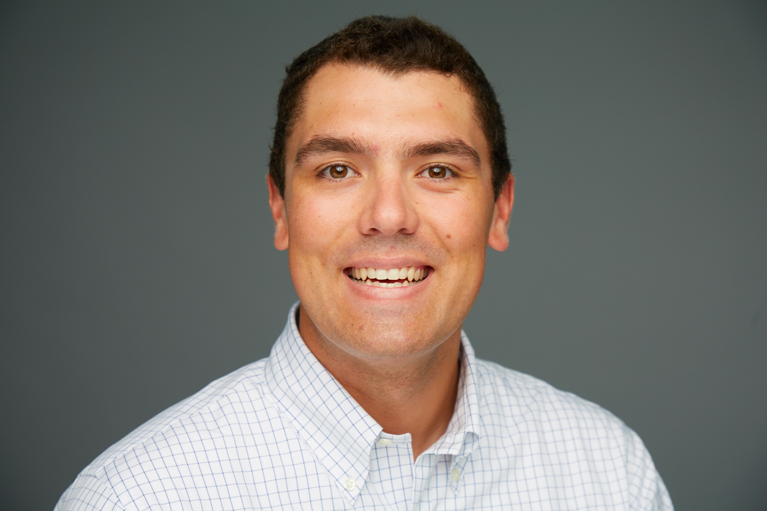

CAM MOLIS

Cam Molis is a third year student at Columbia Law School. He is a member of the Mediation Clinic and a Managing Editor of the Columbia Human Rights Law Review.

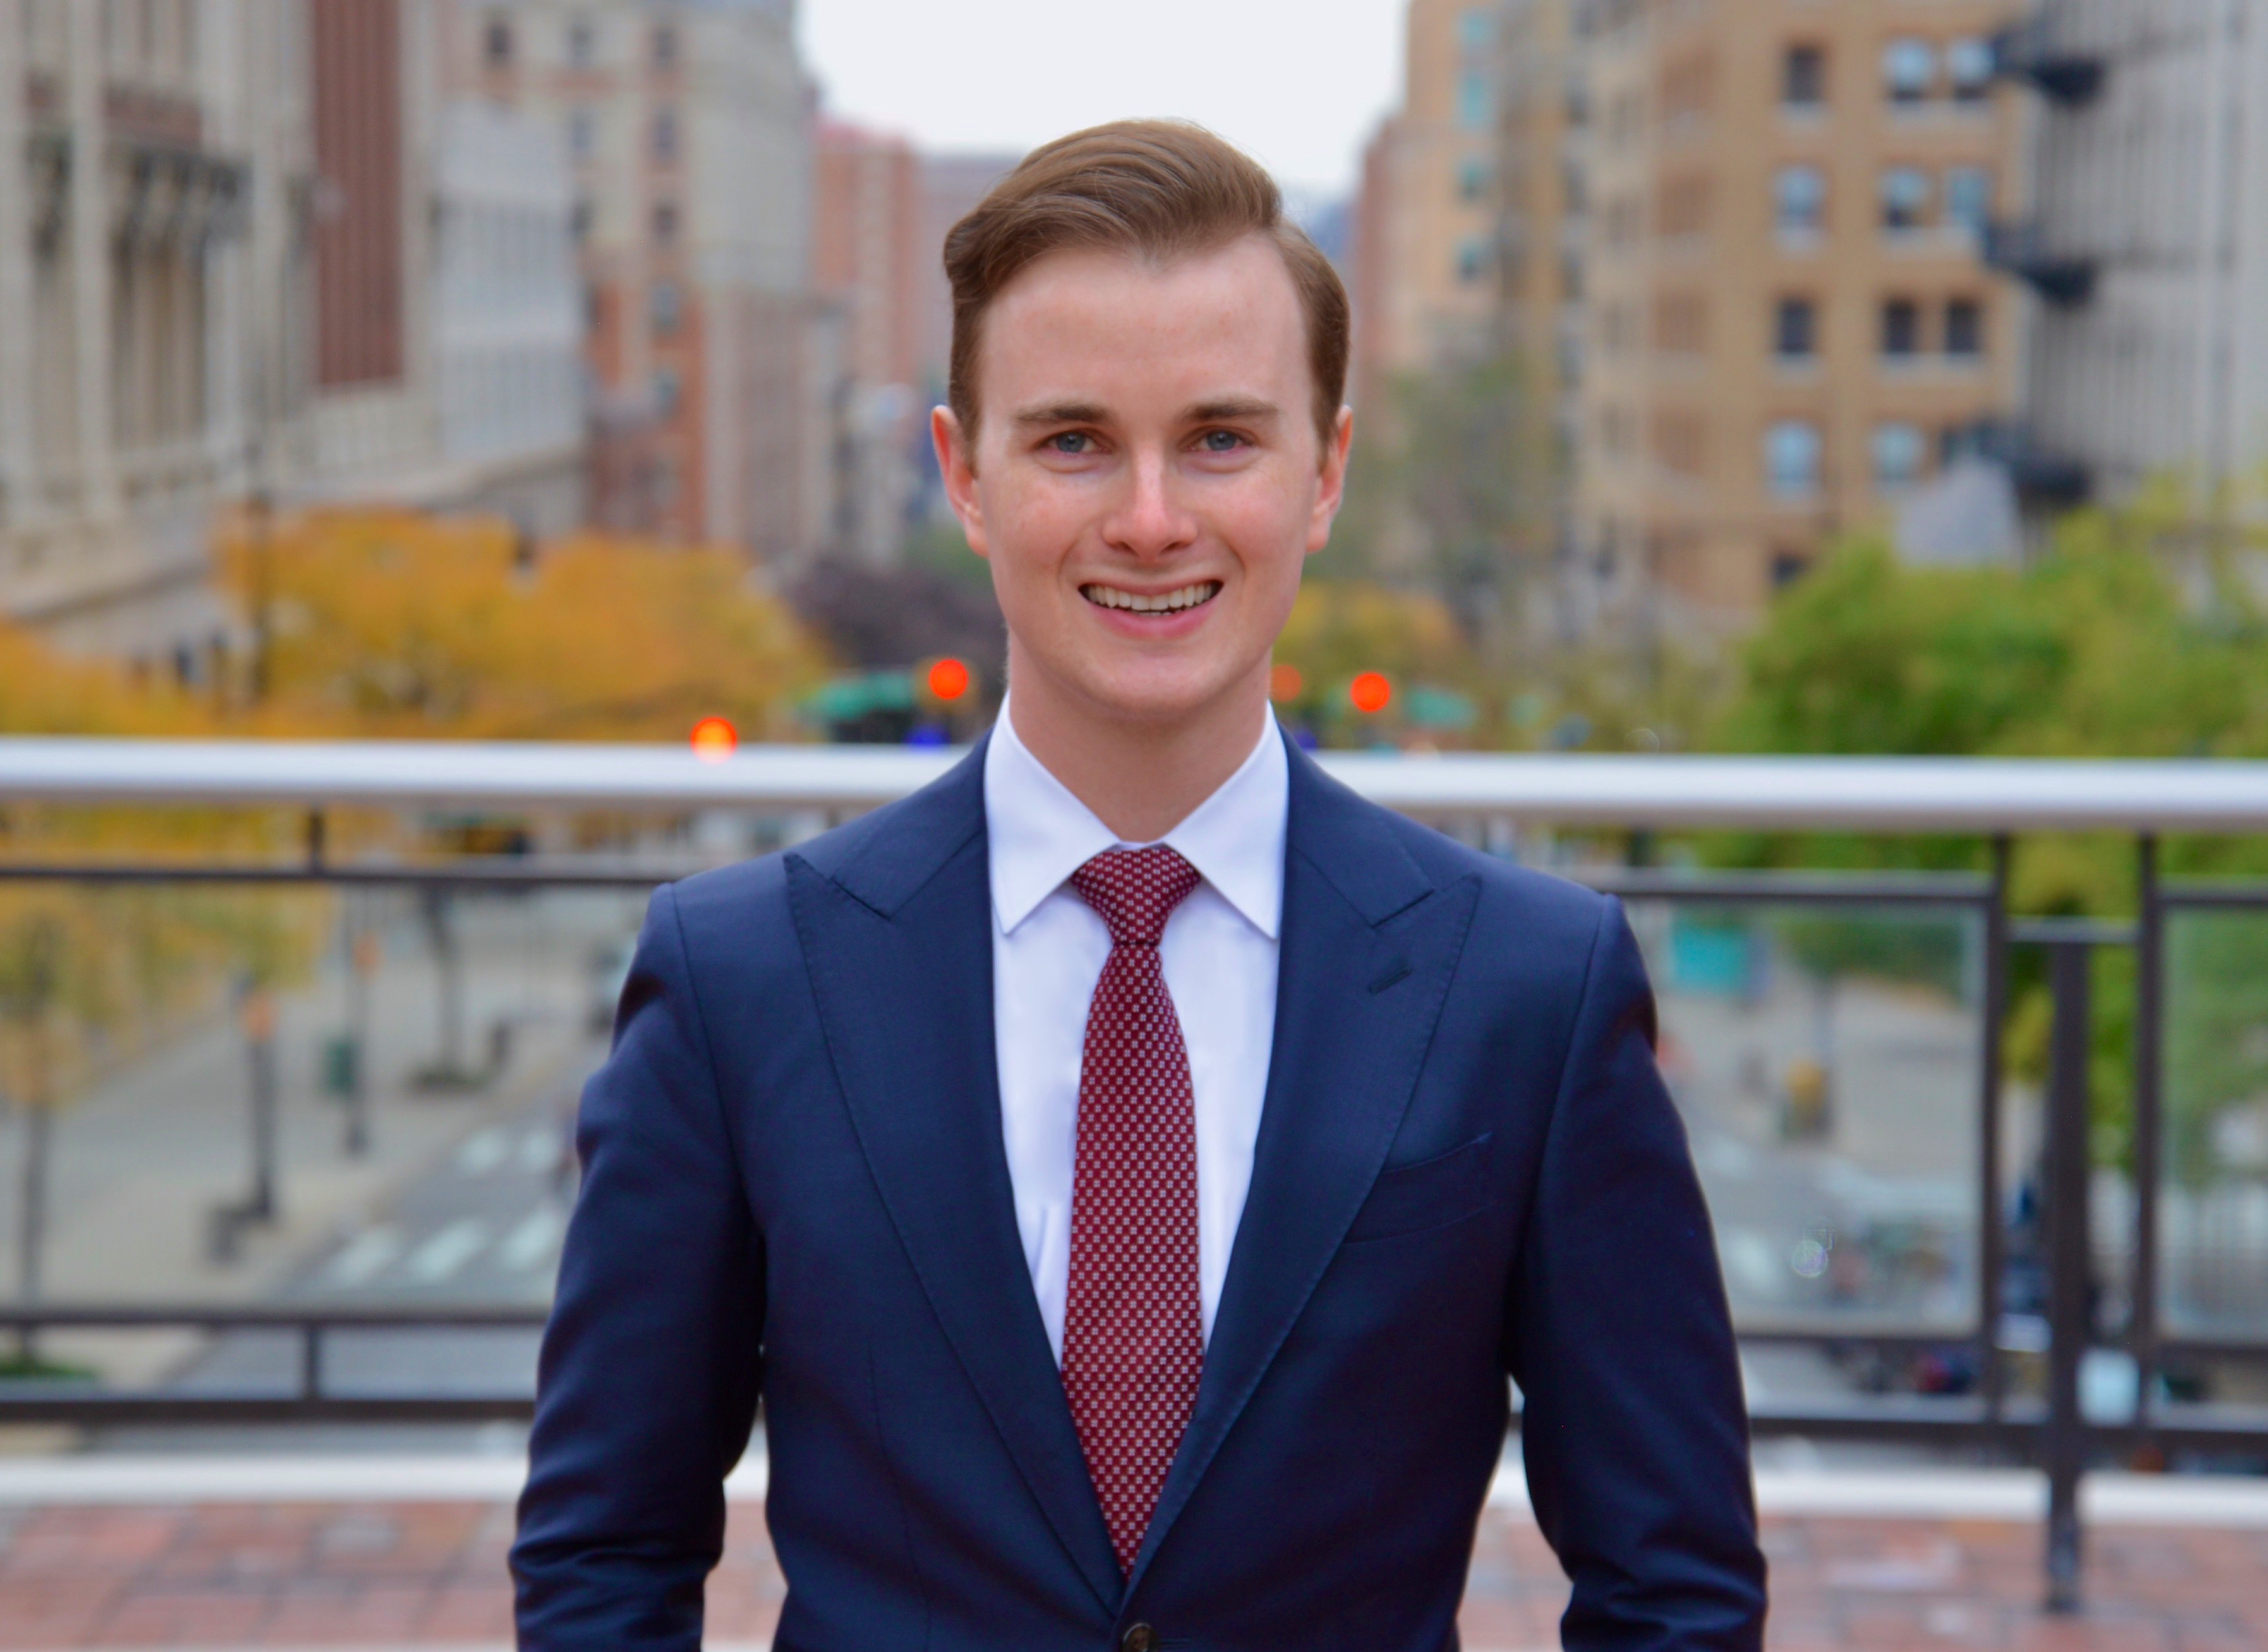

MEYER HORNE

Meyer Horne is a third year student at Columbia Law School. She is a member of the Black Law Students Association and Empowering Women of Color, participates in the Mediation Clinic, and served as a staffer for the Columbia Journal of Race and Law.

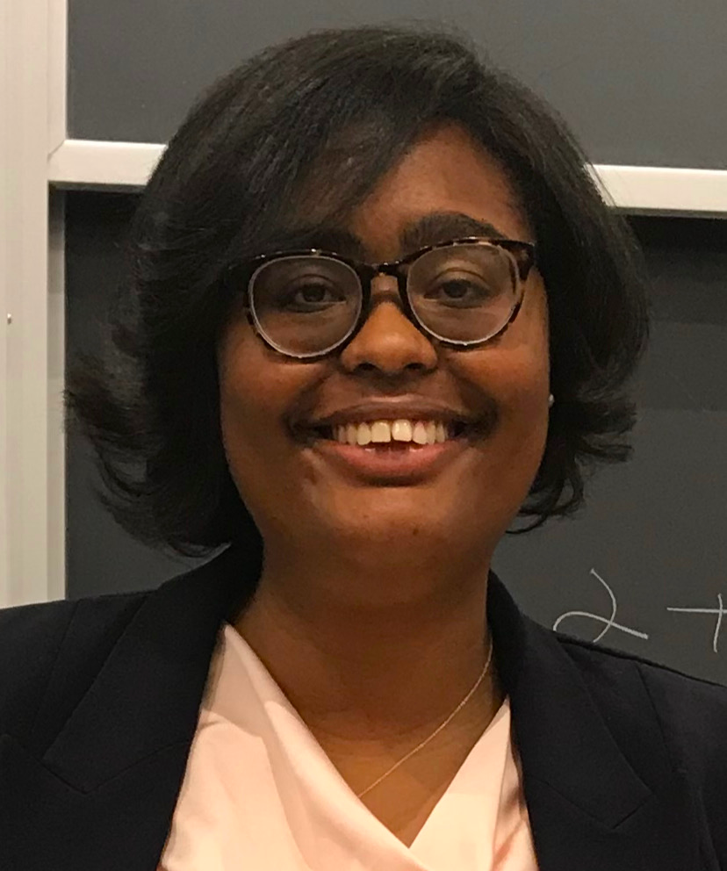

MIE MORIKUBO

Mie Morikubo is a third year student at Columbia Law School. She is a member of the Mediation Clinic and a Managing Editor of the Columbia Law Review.

YOUNG JOON JOO

Young Joo is a third year student at Columbia Law School. He is a member of the Mediation Clinic, the Asian Pacific American Law Students Association, and the South Korean Legal Society.

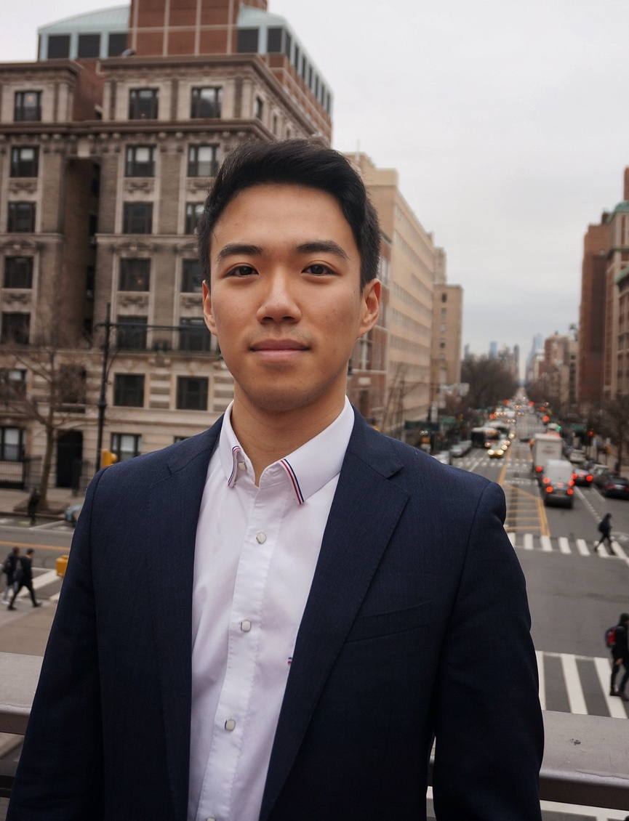

ALEXANDRA CARTER

Alexandra Carter is a Clinical Professor of Law and the Director of the Mediation Clinic at Columbia Law School. In 2019, Professor Carter was awarded the Columbia University Presidential Award for Outstanding Teaching, Columbia University’s highest teaching honor.

Professor Carter is the author of Ask for More: 10 Questions to Negotiate Anything, published by Simon & Schuster on May 5, 2020, which became an instant Wall Street Journal Business bestseller.

Professor Carter’s teaching and research interests lie in the field of alternative dispute resolution, primarily in mediation and negotiation. She is a leading trainer on negotiation and mediation for many from the private and public sectors, including the United Nations, where she designed a negotiation workshop as part of the first ever skills-building summit for female diplomats, entitled “Women Negotiating Peace;” U.S. courts and federal agencies; private corporations and law firms.

Professor Carter serves on the New York State Alternative Dispute Resolution Advisory Committee commissioned by Chief Judge Janet DiFiore; she previously served on the Alternative Dispute Resolution Committee for the New York City Bar Association as well as the Mediator Ethics Advisory Committee for the New York State Unified Court System. She is an admitted mediator for the Southern District of New York.

Prior to joining the Columbia faculty, Professor Carter was associated with Cravath, Swaine & Moore LLP, where she worked as part of a team defending against a multibillion dollar securities class action lawsuit related to the Enron collapse, served as the senior antitrust associate on several multibillion dollar mergers, and handled cases involving copyright law. She also worked as an analyst at Goldman Sachs. She is a former U.S. Fulbright Scholar to Taiwan.

Professor Carter received her Juris Doctor degree in 2003 from Columbia Law School, where she earned James Kent and Harlan Fiske Stone academic honors. She also won the Jane Marks Murphy Prize for clinical advocacy and the Lawrence S. Greenbaum Prize for the best oral argument in the 2002 Harlan Fiske Stone Moot Court Competition. After earning her degree, Professor Carter clerked for the Hon. Mark L. Wolf, U.S. District Court for the District of Massachusetts in Boston.

