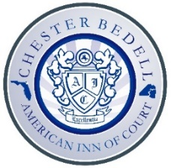
Judge Paul “Bill” Glenn Scholarship

Overview
Through this scholarship, to honor Judge Glenn’s outstanding Inn leadership, the Chester Bedell American Inn of Court seeks to develop young lawyers for future Inn leadership by selecting a barrister to accompany Inn officers at the annual American Inns of Court summit in Florida.
Criteria
- The recipient must be an active barrister of the Chester Bedell American Inn of Court.
- The recipient must show an interest in Inn leadership through attendance at meetings and events and contributions to his or her group.
- The recipient must be a first-time recipient of the scholarship.
Procedures
- A summary of the award overview, criteria, and procedures will be placed on the Inn’s website.
- Payment will come from the scholarship fund set up in memory of Judge Glenn or, if insufficient funds there, from the Inn’s general budget.
- Payment will cover expenses for car transportation at the government rate, one night at a hotel, parking, and the fee to attend the summit, not to exceed $500.
- At the October meeting each year, the President will summarize for all active members the scholarship overview, criteria, and procedures.
- Nominations may be made by anyone (members or non-members) to any member of the Executive Committee in any manner, however informal, and at any time before the February meeting of the Executive Committee.
- At its February meeting each year, the Executive Committee will consider nominees for the scholarship and select a recipient.
- The recipient is recognized at the Chester Bedell American Inn of Court’s annual dinner by the President or someone selected by the President.
- The recipient will be added to a list of recipients of the scholarship on the Inn’s website.

