The January 15, 2020 meeting of the Giles S. Rich American Inn of Court was held at the George Washington University Law School. The meeting was titled “Patent Exhaustion after Lexmark.” It focused on the lay of the land after the Supreme Court’s decision in Impression Prod., Inc. v. Lexmark Int’l, Inc., 137 S. Ct. 1523 (2017).
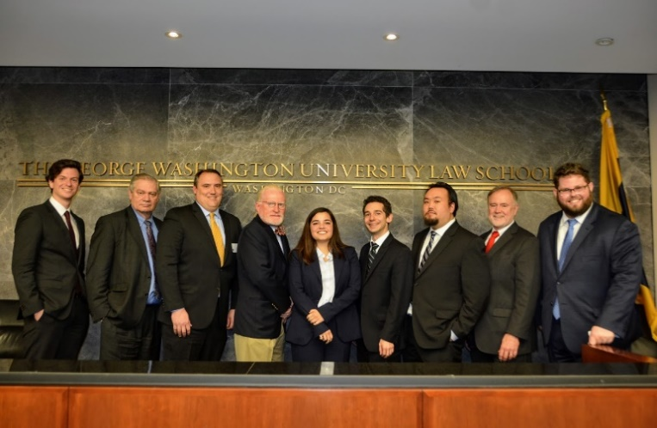
(From right to left: Eric Westerhold; Hon. Theodore Essex; Brian Kacedon; Dean John Whealan; Courtney Crawice; Philip Schwartz, Tim Hsieh; Patrick Coyne; and Patrick Holvey)
The meeting’s panelists included: Hon. Theodore Essex (Ret. USITC ALJ) (Hogan Lovells); Dean John Whealan (GW Law School); and Brian Kacedon (Finnegan Henderson). The panel moderators were Patrick Holvey and Tim Hsieh. The program co-chairs were Patrick Coyne and Patrick Holvey.
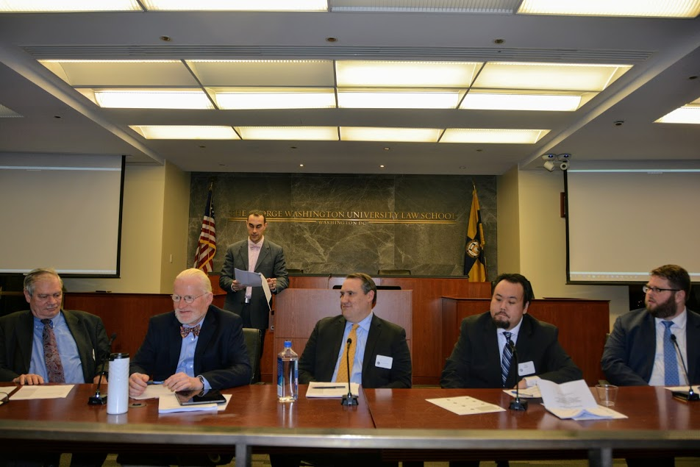
(From right to left: Hon. Theodore Essex; Dean John Whealen; Brian Kacedon; Tim Hsieh; and Patrick Holvey)
The meeting began with three short presentations by young Inn members Philip Schwartz, Courtney Crawice, and Eric Westerhold. These presentation discussed intellectual property exhaustion cases leading up to and including the Supreme Court Lexmark decision. Some of the cases discussed included: Bobbs-Merrill Co. v. Straus, 210 U.S. 339 (1908); Quanta Computer, Inc. v. LG Elecs., Inc., 553 U.S. 617 (2008); and Kirtsaeng v. John Wiley & Sons, Inc., 568 U.S. 519 (2013).
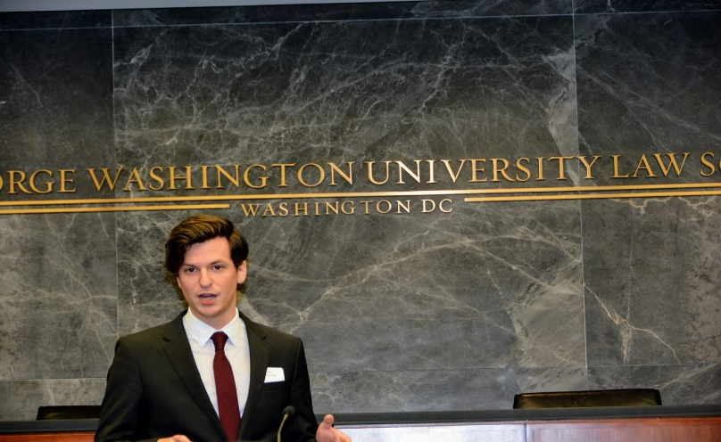(presentation of young Inn member Eric Westerhold)
The meeting then moved to the panel discussion. The panel focused on the practical effect of the Lexmark decision, including the effects of patent exhaustion for licensors/licensees and litigators, the difficulty of contract drafting between sophisticated parties to protect certain intellectual property rights, and possible antitrust concerns that may arise.
At the end of the panel discussion, the panelists took questions from the audience.
Summary by Adi Williams; Photos by Charles Rones.

