On Tuesday, October 16, 2018, the Giles S. Rich American Inn of Court held its monthly program at the United States Court of Appeals for the Federal Circuit, In-House Counsel Practice. The meeting explored the perspectives of in-house counsel, who advise their respective companies on intellectual property issues. The panelists included (as pictured below): Katherine Minarik, General Counsel at cleverbridge; Jonathan Stroud (Chief Patent Counsel at Unified Patents Inc.; Kirsten Braun, Counsel, IP Litigation at AstraZeneca; and Serena Farquharson-Torres, Senior Corporate Counsel, Patents at Bristol-Myers Squibb.
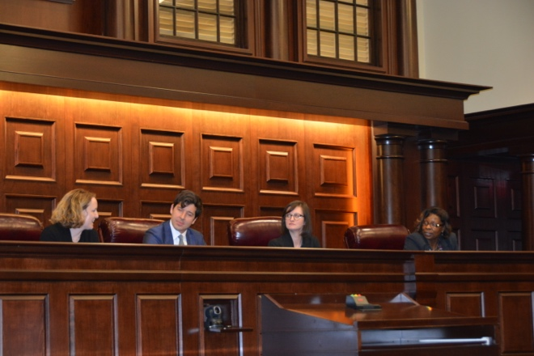
(Speakers as above, left to right.)
Moderators Richard Rainey (Covington & Burling LLP) and Rachel Elsby (Akin Gump) (pictured below with Inn President Judge Ray Chen) both lead the panelists through a discussion on topics ranging from what in-house expectations are of outside counsel, what law firms can or should be doing to increase diversity in the profession (especially in IP), and how in-house teams adapt to changes in patent law, to what developments from the Courts or Congress have impacted corporate IP strategies most significantly.
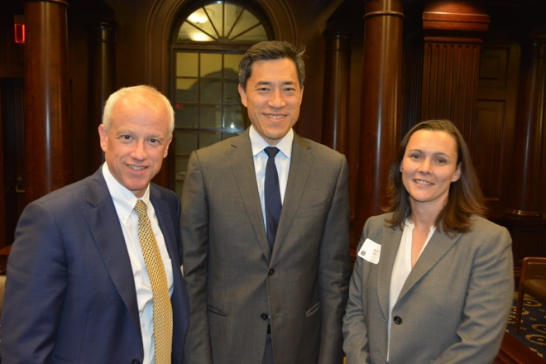
(Richard Rainey, Inn President Judge Raymond Chen, and Rachel Elsby, left to right)
The meeting included a lengthy question-and-answer session with both the moderators and the Inn, and included discussions of portfolio, licensing, and litigation management, the rise of litigation financing in patent law, career advice for younger attorneys, and discussions on staffing, client/attorney relations, and more, as well as an exploration of the problems unique to in-house practice.
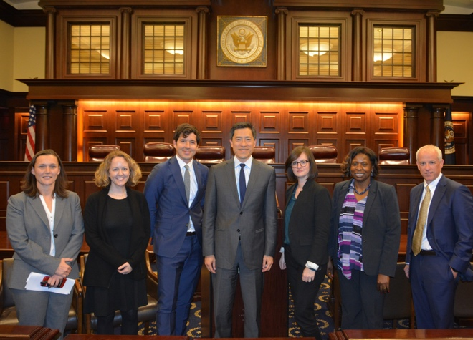
The meeting, hosted by the Giles S. Rich American Inn of Court, was held in the United States Court of Appeals for the Federal Circuit, 717 Madison Place, N.W., beginning at 5:30 p.m. It was preceded by a short reception, and followed by food and drink in the historic Dolly Madison House. It was both well-attended and well-received.
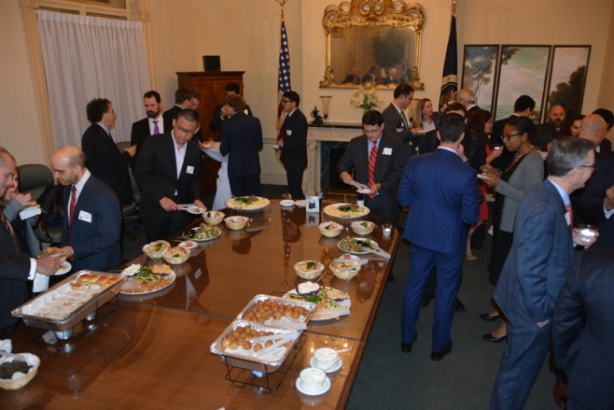
(Excellent food and an open bar drew a sizable crowd at the Dolly Madison House after the program.)
If there are any questions or concerns, please feel free to reach out to Kiley White at whitek@cafc.uscourts.gov.

