MICHAEL R. N. MCDONNELL
AMERICAN INN OF COURT

Member Handbook

http://inns.innsofcourt.org/for-members/inns/the-michael-r-n-mcdonnell-american-inn-of-court

MISSION OF THE AMERICAN INNS OF COURT

The Mission of the American Inns of Court is to foster excellence in professionalism, ethics, civility, and legal skills for judges, attorneys, academicians, and students of the law in order to perfect the quality, availability and efficiency of justice in the United States.

Contents
Introduction 1
Professional Creed 1
American Inns of Court 2
Inn Governance 3
Attendance Policy 4
Guest Policy 4
Continuing Legal Education Credit 4
Membership 4
Member Profile 5
Pupilage Groups 5
Mentoring 5
Annual Dues 6
Meetings and Programs 6
Benefits from the Foundation 7
Information 8

Attachments
- How to Access and Update Your Profile on the American Inns of Court Website
- Program Submission Form

Introduction
This Handbook will introduce you to the American Inns of Court and to the Michael R. N. McDonnell American Inn of Court. Its purpose is to acquaint you with the history of the Inns of Court movement in the United States and in Florida, and with the operation of the Michael R. N. McDonnell American Inn of Court.

Professional Creed
Whereas, the Rule of Law is essential to preserving and protecting the rights and liberties of a free people; and
Whereas, throughout history, lawyers and judges have preserved, protected and defended the Rule of Law in order to ensure justice for all; and
Whereas, preservation and promulgation of the highest standards of excellence in professionalism, ethics, civility, and legal skills are essential to achieving justice under the Rule of Law;
Now therefore, as a member of an American Inn of Court, I hereby adopt this professional creed with a pledge to honor its principles and practices:
- I will treat the practice of law as a learned profession and will uphold the standards of the profession with dignity, civility and courtesy.
- I will value my integrity above all. My word is my bond.
- I will develop my practice with dignity and will be mindful in my communications with the public that what is constitutionally permissible may not be professionally appropriate.
- I will serve as an officer of the court, encouraging respect for the law in all that I do and avoiding abuse or misuse of the law, its procedures, its participants and its processes.
- I will represent the interests of my client with vigor and will seek the most expeditious and least costly solutions to problems, resolving disputes through negotiation whenever possible.
- I will work continuously to attain the highest level of knowledge and skill in the areas of the law in which I practice.
- I will contribute time and resources to public service, charitable activities and pro bono work.
- I will work to make the legal system more accessible, responsive and effective.
- I will honor the requirements, the spirit and the intent of the applicable rules or codes of professional conduct for my jurisdiction, and will encourage others to do the same.

American Inns of Court
The American Inns of Court is the fastest growing legal organization in the country. Today, there are nearly 400 American Inns of Court in 48 states, the District of Columbia, and Guam. More than 30,000 judges, lawyers, law professors and law students are currently members of the American Inns of Court, including 40 percent of all federal judges and over 1500 state judges.
American Inns of Court are patterned after the English Inns of Court, which began in 1292, when King Edward I directed his Chief Justice to satisfy a growing need for skilled advocates at the Royal Court at Westminster. The English Inns of Court grew in number and importance during the Middle Ages. They emphasized the value of learning the craft of lawyering from those already established in the profession. Their collegial environment fostered common goals and nurtured professional ideals and ethics.
In 1977, Chief Justice Warren E. Burger and other American lawyers and judges spent two weeks in England as part of an Anglo-American Exchange. They were particularly impressed by the collegial approach of the English Inns of Court and by the way the Inns passed on to new lawyers the decorum, civility and professional standards necessary for a properly functioning bar. Following his return, Chief Justice Burger authorized a pilot program that could be adapted to the realities of law practice in the United States. Chief Justice Burger, former Solicitor General Rex Lee and Senior United States District Judge A. Sherman Christensen founded the first American Inn of Court in 1980. The Inn was affiliated with the J. Reuben Clark School of Law at Brigham Young University in Provo, Utah. The number of Inns increased slowly at first, but the growth of the movement began to accelerate in 1985 with the creation of the American Inns of Court Foundation.
The Chester Bedell American Inn of Court, Florida's first American Inn of Court, was founded in 1985 in Jacksonville, Florida. The Michael R. N. McDonnell American Inn of Court in Collier County was formed in 1995. There are currently 38 Inn Chapters in the State of Florida.
American Inns of Court are designed to improve the skills, professionalism and legal ethics of the bench and bar. They help lawyers become more effective advocates with a keener ethical awareness by providing them the opportunity to learn side-by-side with the most experienced judges and lawyers in their community. The objectives of each Inn are as follows:
1. To establish a society of judges, lawyers, legal educators, law students and others to promote excellence in legal advocacy in accordance with the Professional Creed of the American Inns of Court;
2. To foster greater understanding and appreciation for the adversary system of dispute resolution in American law, with particular emphasis on ethics, civility, professionalism, and legal skills;
3. To provide significant education experiences that will improve and enhance the abilities of lawyers as counselors and advocates and of judges as adjudicators and judicial administrators;
4. To promote interaction and collegiality among all legal professionals in order to minimize misapprehensions, misconceptions and failures of communication that obstruct the effective practice of law;
5. To facilitate the development of law students, recent law school graduates and less experienced lawyers as skilled participants in the American court system;
6. To preserve and transmit ethical values from one generation of legal professionals to the next; and
7. To build upon the genius and strengths of the common law and the English Inns of Court and to renew and inspire joy and zest in legal advocacy as a service worthy of constant effort and learning.

Inn Governance
Governance of the Michael R. N. McDonnell American Inns of Court is entrusted to the Executive Committee. The Executive Committee members include: President, President-Elect, Secretary/Treasurer, Immediate Past President, Program Director, Membership Director, Mentoring Director, CLE Coordinator, Judicial Liaison (non-voting member) and at-large members.

The President and President-Elect must be Masters or Barristers. The other officers and Executive Committee members may be drawn from any membership category.

Besides their regular duties, members of the Executive Committee also nominate the Inn's officers for the following year. Officers serve for a one-year term and are eligible for successive terms.

Attendance Policy
Membership in the Inn is a privilege. The Inn furthers its goals by the active involvement and efforts of its members. Therefore, all members are expected to attend Inn meetings and participate in Inn activities.

Guest Policy
The Inn's programs are primarily for the members' benefit. However, members may invite guests from time to time. Members who wish to invite guests must inform the President in advance of the meeting of their guests' names. They must also agree to be responsible for the cost of the guests' dinners. Members may pay for their guests prior to the meeting or at the time of the meeting.

Continuing Legal Education Credit
The Inn has been certified as a CLE provider by the Florida Bar Continuing Legal Education Committee. CLE Credits are applied for by the Inn throughout the year. CLE course numbers are reported by the CLE Coordinator to the membership as credits are awarded by the Florida Bar. They are also posted online on our Inn’s web site. Each member reports his or her own CLE credits to the Florida Bar.

Membership
The membership of the Michael R. N. McDonnell American Inn of Court is divided into three classifications. "Masters of the Bench" include lawyers with ten or more years of experience and federal, state, and local judges, and law professors. "Barristers" include lawyers with five to up to ten years of experience. "Associates" include lawyers with up to five years of experience.

The Inn's members are drawn primarily from Collier County. Membership is open to all qualified persons, regardless of race, color, sex, age, religion, national origin, sexual orientation, or handicap. Thus, the Michael R. N. McDonnell American Inn of Court reflects the rich diversity of the bench and bar and includes representatives of the plaintiffs' bar, defense counsel, solo practitioners, government lawyers, corporate counsel, law professors, persons working in large and small firms, and federal, state, and local trial and appellate judges.

Efforts are made to ensure that no law firm or type of practice is disproportionately represented. In addition to the active members, the Inn’s Executive Committee may extend emeritus membership status to members. Emeritus members may participate in the Inn's education and social programs at their own expense. Emeritus members may or may not be assigned to a pupilage group of the Inn.

Member Profile
In order to ensure that our Inn has accurate and up to date contact information for our members, members are expected to access and update their member profile found on the national site. Login instructions are found at the end of this Handbook, and can also be accessed at:
http://home.innsofcourt.org/AIC/How_to_Login_and_Update_My_Profile.aspx

Pupilage Groups
Pupilage groups are the core membership unit of the Inn. The pupilage groups consist of Masters of the Bench, Barristers and Associates who generally would not otherwise encounter each other frequently in their daily work. Pupilage groups are normally constituted for a single membership year. Each pupilage group meets to select a presentation topic, and draft, practice and prepare a program that is presented to the membership. The pupilage group presents that topic at a regular meeting of the Inn.

The pupilage groups are encouraged to meet to promote camaraderie among the pupilage group members. Each pupilage group is led by one or more Group Leaders, along with a sitting judge. The Group Leaders are responsible for convening the group, for assuring that the group members attend the Inn's Membership Meetings and activities, and for promoting contacts among group members between Inn meetings.

The pupilage groups provide Inn members an opportunity to become better acquainted with other lawyers practicing in Collier County. The pupilage groups are the principal component of the Inn's mentoring activities. Their diverse membership is intended to build an intergenerational relationship that encourages frank and personal discussion of matters of practice, ethics, civility, and all other aspects of the practice of law. The most experienced members of the pupilage group are encouraged to pass on the best of the practice to the less experienced members.

Pupilage groups are asked to select topics by October 1st to avoid duplication of subject matter, and to encourage an interesting variety of presentations for our members. A catalog (in PDF) and a searchable program library is available at:
http://home.innsofcourt.org/AIC/For_Leaders/Program_Library/AIC/AIC_For_Members/AIC_Program_Lib/Program_Library.aspx

Pupilage groups may also create a program of their own.

Pupilage groups are encouraged to submit their programs for inclusion in the Program Library hosted by national. A form can be found online via the link above.

Mentoring
During the 2018-19 Season, the Inn launched a new activity-focused mentoring program designed to provide guidance to attorneys new to the Florida Bar that will instill the importance of professionalism and competence. By harnessing the experience of high principled, successful practitioners, attorneys new to the Florida Bar will be offered a resource that will spare them from experiencing many of the pitfalls that are a by-produce of unfamiliarity with the practice of law in Florida. The Inn’s Mentoring Program is designed to achieve its mission by organizing and hosting intentionally planned mentoring-focused activities through the year on a regular basis outside of the regular Inn of Court meetings and Pupillage groups. These mentoring-focused activities will be designed to encourage and create opportunities for mentoring relationships to be created naturally and informally between Inn of Court members who are new to the Florida Bar and seek mentoring relationships and Inn of Court members who are high principled, successful practitioners willing to serve as mentors. For more on the Program, see the 2018-19 Mentoring Program Handbook.

Annual Dues
The annual dues for non-judicial members of the Inn are $425. Our Inn’s Taxpayer Identification Number is 65-0561107. The funds provided by the dues defray the Inn's operating expenses, including the cost of the members' dinners at the monthly Inn meetings and dues to the American Inns of Court Foundation.

Meetings and Programs
Our meetings are typically held at the Cypress Room at the Club at Naples Bay Resort. The Cypress Room is in the part of the property located at the corner of US-41 and Sandpiper Street – not in the main hotel. For navigation, the address is 1800 Tamiami Trail East.
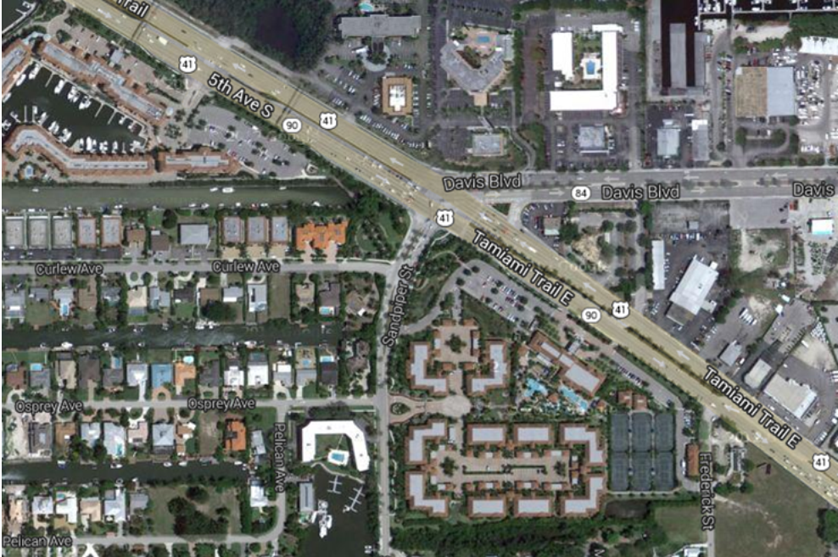
The Cypress Room

Each meeting begins with a social half-hour from 5:30-6:00 p.m. Announcements are made at 6:00 p.m. Dinner is served from 5:45 p.m. to 6:10 p.m., and the presentation by the pupilage group begins at 6:10 p.m. The meeting will be adjourned at 7:00 p.m. sharp when we all go home.

The programs are the heart of the monthly meetings. They involve practical legal skills with an emphasis on ethics, civility and professionalism in lawyering. They generally involve a demonstration or presentation of principles, skills, techniques, and relationships involved in trial and appellate court proceedings and in activities preliminary to courtroom appearances. The programs also incorporate opportunities for participation, critique, and discussion.

Benefits from the Foundation
Members of the Michael R. N. McDonnell American Inn of Court receive benefits from the American Inns of Court Foundation. They receive a subscription to The Bencher, the Foundation's bimonthly newsletter, and a national membership directory as well as access to resources at InnsofCourt.org. Members of local Inns are also entitled to attend the annual Celebration of Excellence at the United States Supreme Court. Members may also participate in the annual trip to Washington, D.C. to be sworn in and admitted to practice in the United States Supreme Court. Members traveling to England may also obtain letters of introduction to one of the four English Inns of Court.

Information

For information pertaining to our local Collier County Inn please do not hesitate to contact Christopher D. Donovan, Esq. at (239) 213-3865 or cdonovan@ralaw.com.

For further information about your membership in the American Inns of Court Foundation, please contact the Foundation office at: American Inns of Court Foundation, 225 Reineker Lane, Suite 770, Alexandria, Virginia 22314, (703) 684-3590, (703), 684-3607 (fax), or www.innsofcourt.org.

