Rich Inn of Court
Program 1: Patent Trial and Appeal Board
September 16, 2015

PROGRAM MATERIALS
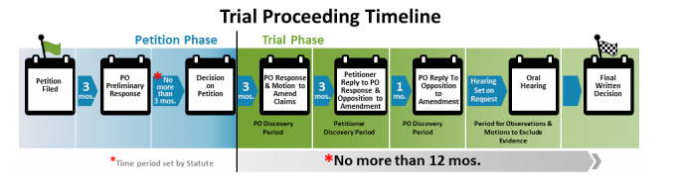
Topic 1: Patent Owner Preliminary Response & Submission of New Testimonial Evidence
Proposed Rule 42.107(a): The patent owner may file a preliminary response to the petition. The response may set forth the reasons why no inter partes review should be instituted under 35 U.S.C. 314 and can include supporting evidence. The preliminary response is subject to the word count under
§ 42.24.
Proposed Rule 42.108(c): Inter partes review shall not be instituted for a ground of unpatentability unless the Board decides that the petition supporting the ground would demonstrate that there is a reasonable likelihood that at least one of the claims challenged in the petition is unpatentable. The Board's decision will take into account a patent owner preliminary response where such a response is filed, but supporting evidence concerning disputed material facts will be viewed in the light most favorable to the petitioner for purposes of deciding whether to institute an inter partes review. If the patent owner submits supporting evidence with its preliminary response, the petitioner may seek leave to file a reply to the preliminary response in accordance with § 42.24(c).
Topic 2: Claim Construction Standard
Proposed Rule 42.300(b): A claim in an unexpired patent that will not expire before a final written decision is issued shall be given its broadest reasonable construction in light of the specification of the patent in which it appears.
Topic 3: What’s Not in the Proposed Rules
Claim amendment practice: to be developed through PTAB decisions
- Idle Free Systems, Inc. v. Bergstrom, Inc., IPR2012-00027, Paper 26, June 11, 2013
- MasterImage 3D, Inc. v. RealD Inc., IPR2015-00040, Order re Motion to Amend, Paper 42,
July 15, 2015

